Crowmoor Primary School & Nursery
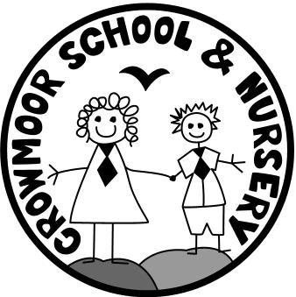
Crowmere Road
Shrewsbury
Shropshire
SY2 5JJ
Telephone: 01743 235549

admin@crowmoorschool.co.uk
www.crowmoorschool.co.uk
Acting Headteacher: Mrs J Grice
School Business Manager: Miss H Cave

Term Dates for the 2024/2025 Academic Year Listed Below:

Autumn Term 2024

PD Day (School closed): Monday 2nd September 2024
PD Day (School closed): Tuesday 3rd September 2024
PD Day (School closed): Wednesday 4th September 2024
Term time: Thursday 5th September 2024 – Friday 25th October 2024
Half Term: Monday 28th October 2024 - Friday 1st November 2024
Term Time: Monday 4th November 2024 - Friday 20th December 2024
Christmas Holidays: Monday 23rd December 2024 - Monday 6th January 2025

Spring Term 2025

PD Day (School closed): Monday 6th January 2025
Term time: Tuesday 7th January 2025 - Friday 14th February 2025
Half Term: Monday 17th February 2025 - Friday 21st February 2025
Term time: Monday 24th February 2025 - Friday 11th April 2025
Easter Holiday: Monday 14th April 2025 - Friday 25th April 2025

Summer Term 2025

Term time: Monday 28th April 2025 - Friday 23rd May 2025
Bank Holiday (School closed): Monday 05th May 2025
Bank Holiday (School closed): Monday 26th May 2025
Half Term: Monday 26th May 2025 - Friday 30th May 2025
Term time: Monday 2nd June 2025 - Monday 21st July 2025
PD Day (School closed): Monday 21st July 2025

