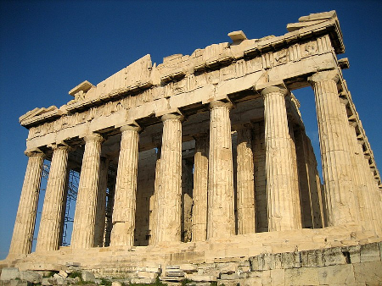 

Curriculum Information for parents/carers

Year 6 – Willow – Summer 1

In Year 6, we aim to help the children build their independence, in order to prepare them for secondary school; this is supported by the children reading daily, practising their spellings and reinforcing their classwork at home. We will also be preparing to take our SATs tests from **Monday 13th to Thursday 16th May**. Let’s get revising!

**Physical Education**

- Raising tactical awareness in striking and fielding, as well as types of dance through time.

**Science**

- Investigating significant scientists and inventors, including Marie Maynard Daly and Steve Jobs.

**Personal, Social, Health, Economic**

- Exploring mental health, managing change and managing time.

**Modern Foreign Language (French)**

- Revisiting terminology of conversations and interaction in shops.

**Maths**

- Building our understanding of shape, position and direction and these skills are applied to everyday life.

**Geography**

- Exploring climates and landscapes across Europe, as well as understanding forms of generating power.

**English - Writing**

- Writing for specific purposes, demonstrating the expected range of punctuation and vocabulary.

**Computing**

- Develop our understanding of media, how can we create our own ensuring we know our own and others rights.

**English - Reading**

- Reading “Who Let the Gods Out” - a book about when Virgo comes to earth trying to complete a mission.

**Religious Education**

- Exploring Christianity, how Christians live and answering ‘What would Jesus do?’

**Design and Technology**

- Creating structures fit for purpose, combing design with rigidity.

**History**

- Learning about Ancient Greece, what happened and how it has affected us today.

**Music**

- Learning how to play chords and follow patterns to create music on the ukulele.

**Art and Design**

- Exploring the world around us, building skills to develop detail across a range of mediums.