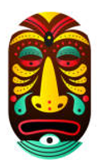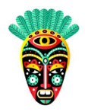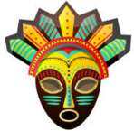

**Design and Technology**

- Explore the use of textiles through creating an Ancient Mayan headdress and sewing a Mayan cloak.

**English - Writing**

- Develop grammatical techniques in writing to vary their sentence structure to make their writing more interesting.

**History**

- Research around the Ancient Mayan civilisation’s calendar, writing, numbers, myths, murals and Gods.

**English - Reading**

- Children will delve into ‘Oh Maya Gods!’ They will demonstrate a wide range of reading comprehension skills as we progress throughout the story.

**Art and Design**

- Explore Southern American pieces of artwork inspired by the Ancient Mayans.

**Maths**

- Further develop their Mathematical knowledge and use previously learned skills through: Shape, Position and Direction and Statistics.

**Modern Foreign Language (French)**

- Learn how to describe their school life in French.

**Music**

- Build confidence and ability when playing the Ukulele.

**Science**

- Children will be investigating the properties and changes in materials.

Curriculum Information for parents/carers

Year 5 – Oak – Summer 1

In Year 5, we aim to develop the children’s independence and responsibilities. They will see the positive relationship a good attitude to learning has on their achievements.

**Religious Education**

- Research into Christianity “For Christians, what kind of King is Jesus?”

**Geography**

- Explore both North and South America by comparing the climate, human and physical geographical features to the UK.

**Computing**

- Creating media through vector graphics.

**Physical Education**

- Develop their striking and fielding skills through rounders.

**Personal, Social, Health, Economic**

- We will explore how the children can take care of their own physical health and wellbeing.