+-

**English - Writing**

- Develop grammatical techniques in writing to vary their sentence structure to make their writing more interesting.

**History**

- Research and learn about the life of Henry VIII.

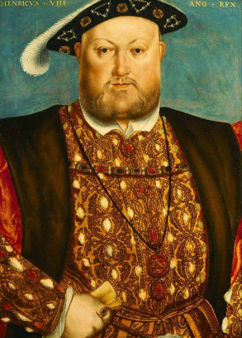

**English - Reading**

- Children will read Treason by Berlie Doherty. The children will demonstrate their reading comprehension skills throughout the story.

**Art and Design**

- Explore using pen, charcoal, felt tips. Make maquettes, paper clothes and sculpt models.

**Maths**

- Further develop their Mathematical knowledge and use previously learned skills through: fractions, money, time, shape and statistics.

**Modern Foreign Language (French)**- Learn vocabulary to describe their school in French. 

**Music**

- Build confidence and ability when playing the recorder.

**Science**

- Children will be learning how animals stay healthy and survive. They will learn about skeletons and muscles.

Curriculum Information for parents/carers

Year 3 – Hazel – Summer 1

In Year 3, we aim to help the children build their independence, resilience and love of learning; this is supported by the children reading daily, practising their spellings and reinforcing their classwork at home.

**Religious Education**

- Research into Christianity – what was the impact of the Pentecost?

**Geography**

- Explore our local town of Shrewsbury.

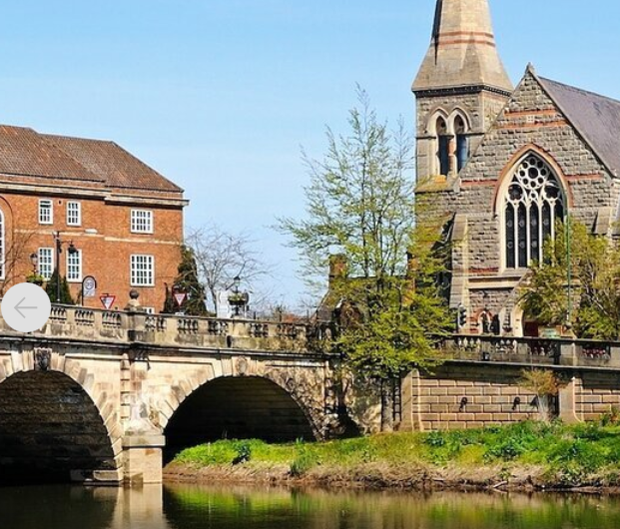

**Computing**

- Creating media using desktop publishing

**Design and Technology**

- Discover the exciting and diverse choice of food available around the world.

**Physical Education**

- Develop their striking and fielding skills through games.

**Personal, Social, Health, Economic**

- Explore their personal strengths and achievements.