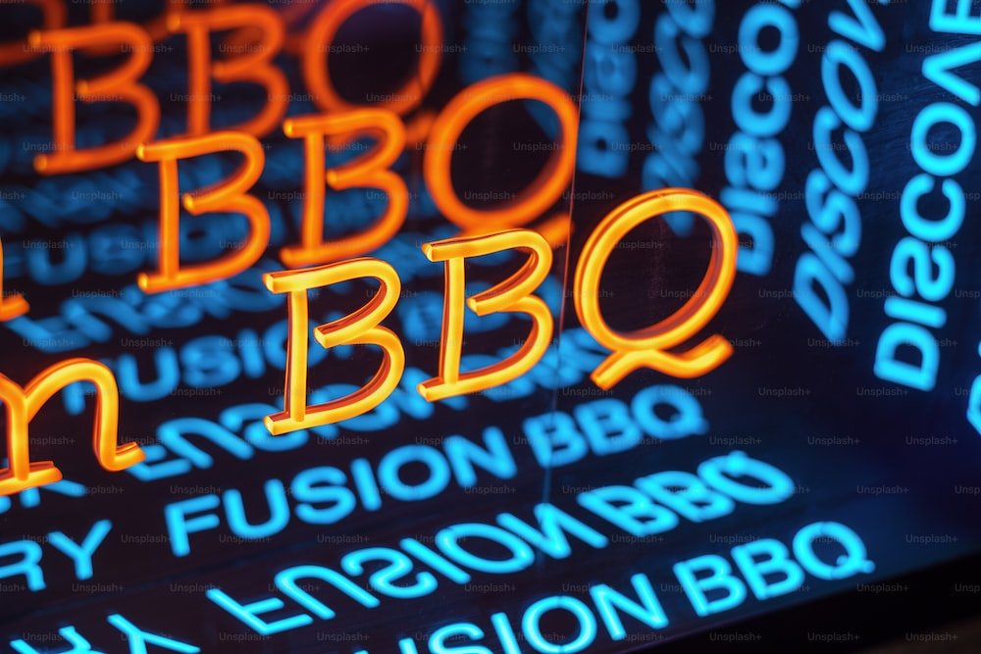**COMMUNITY BBQ**

**SHREWSBURY BAPTIST CHURCH**

**WELCOMES YOU**

**14 JULY 6:00PM**

**COME AND ENJOY GREAT FOOD**

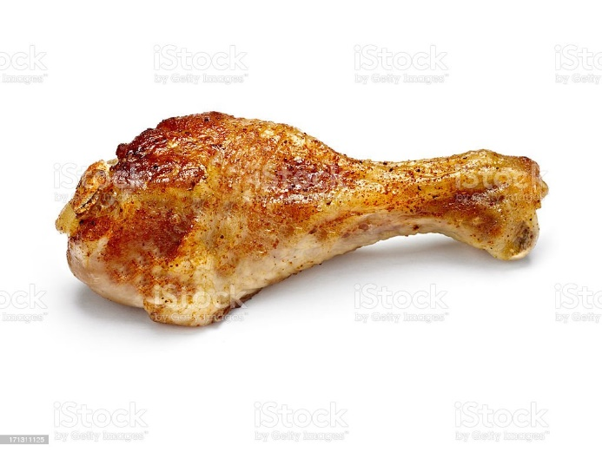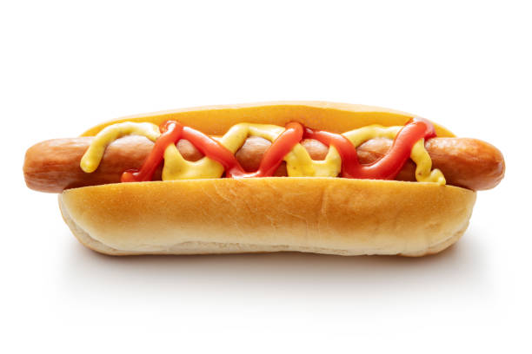

**NO CHARGE FOR THIS EVENT**

**SHREWSBURY BAPTIST CHURCH CROWMOOR SY2 5JJ**

**BOUNCY CASTLE**

FACE

PAINTING