

***UNDERSTANDING YOUR CHILD WORKSHOP***

**Come and join us for a 2 hour workshop**

**on:**

Monday

24

th

April 2023

From 10.00am to 12.00pm

At The Zone Community Hub

Linden Way

Market Drayton

TF9 1QT

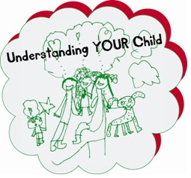

o

*Would you like to know more about*

*your child’s development?*

o

*Do you*

*need support to*

*understand*

*your child’s behaviour?*

o

*Would you like a chance to meet*

*with other parents with children of a*

*similar age?*

To book a place on one of our

workshops

or for

further information on the

services the

Parenting Team

offers

please email

Parenting.team@shropshire.gov.uk

o

r us call on

: 01743 250950