Crowmoor Primary School & Nursery
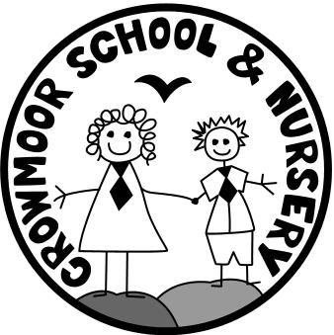
Crowmere Road
Shrewsbury
Shropshire
SY2 5JJ
Telephone: 01743 235549
Fax: 01743 243129

admin@crowmoorschool.co.uk
www.crowmoorschool.co.uk
Acting Headteacher: Mrs J Parkhurst
Acting Deputy Headteacher: Mr.P.Reynolds
School Business Manager: Miss H Cave

16th February 2023

Dear Parents/Carers,

Easter Competition – Spring 2023

The School will be holding four competitions based on an Easter theme. The Mayor has kindly agreed to visit the School and judge the competitions, which will be held on Wednesday 29th March 2023.

The categories for the competitions are listed on the back of this letter. The competition is, as always open to all pupils and parents/carers. Please ensure that your child’s name and class are clearly marked, otherwise they cannot be judged. Entries should be made and constructed at home and must be in School on Wednesday 29th March ready for judging. All competition entries must be collected at the end of the school day on Wednesday 29th March. After this time, entries will be disposed of if uncollected.

If you have any queries, please contact the office for further information.

Yours sincerely

Jayne Parkhurst
Acting Head teacher
JC/LETTERS/FEB23

Easter Garden
This is a traditional Easter activity; a garden is made on a plate, on a tin lid, in a metal food container or on a tray. It must contain water, which represents baptism and life; spring flowers/greenery to represent growth/rebirth; a cross made from wood to show the sacrifice made by Christ; a cave or rocks to represent the tomb and sometimes eggs to show renewal and new life.

Easter Head-Gear
An existing hat or cap decorated on with an Easter theme with Easter artefacts: eggs, rabbits etc. or a totally original piece of headgear made for the occasion.

Easter - Egg Character
Make a hardboiled egg into a character dressed up e.g. a motor racing driver, a space man etc. with an appropriate name.

Easter Model/Sculpture
An Easter themed poem, piece of art, picture, sculpture, model etc.

