Chestnut Weekly News 18.11.2022

What a lovely and busy week we have had. The children have been amazing at thinking about and carrying out friendship week. We have talked about what makes a good friend, how to be a good friend and thought about kindness. We have completed activities, made our kindness door poster and helping hands doodle sheet. The children have particularly liked sharing their super power of kindness.
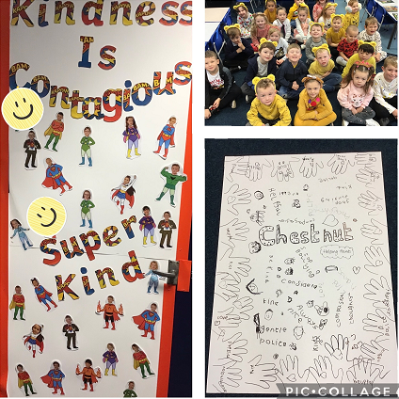
We have been busy practising our Christmas performance, thank you for the costumes that have been brought into school so far. Please feel free to send them in anytime, please also label them with your child’s name.
We have been reading ‘Owl Babies’ this week and getting to know the text, ready to write our own stories in the next couple of weeks about a nocturnal animal. In maths we have been solving addition problems and adding two numbers together. We have also been learning to use number lines to help us.
Enjoy the weekend
Miss Roberts and Miss Harrison

