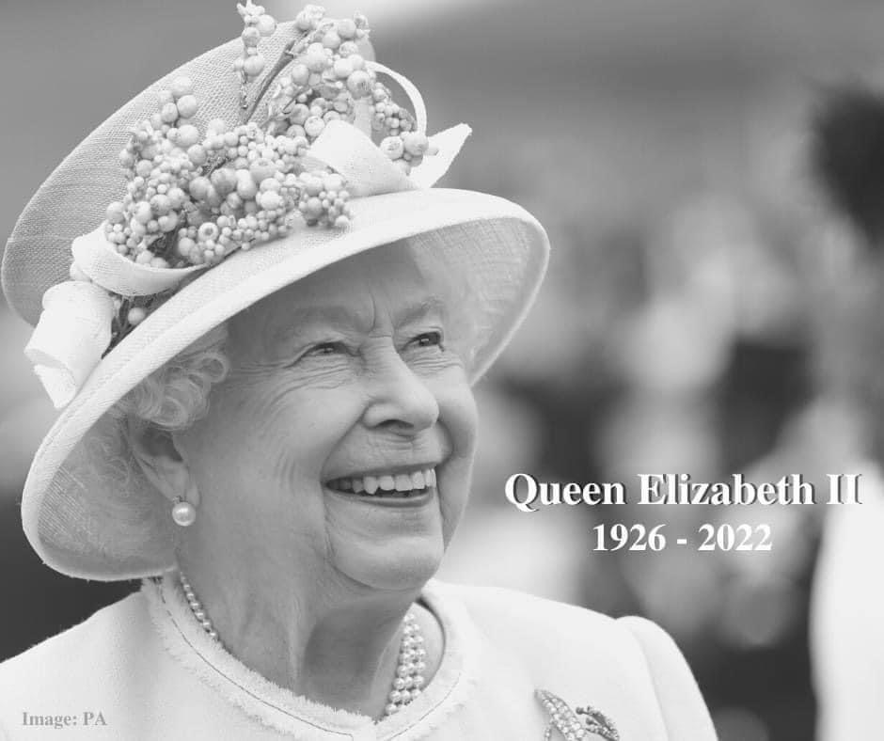

Crowmoor Primary School, it’s staff, pupils and governors send their condolences to the Royal Family at this very sad time and express their gratitude for the consistent and selfless dedication and public service shown by Queen Elizabeth II.
A truly incredible sovereign, wife, mother, grandmother and great grandmother.
She will be greatly missed.
Our thoughts and prayers are with her family at this sad time.

