Comms for Educational Bulletin and School Nurses
Updated: 28.03.22

COVID-19 Vaccination Programme Update: vaccination offer to all 5 to 11-year-olds
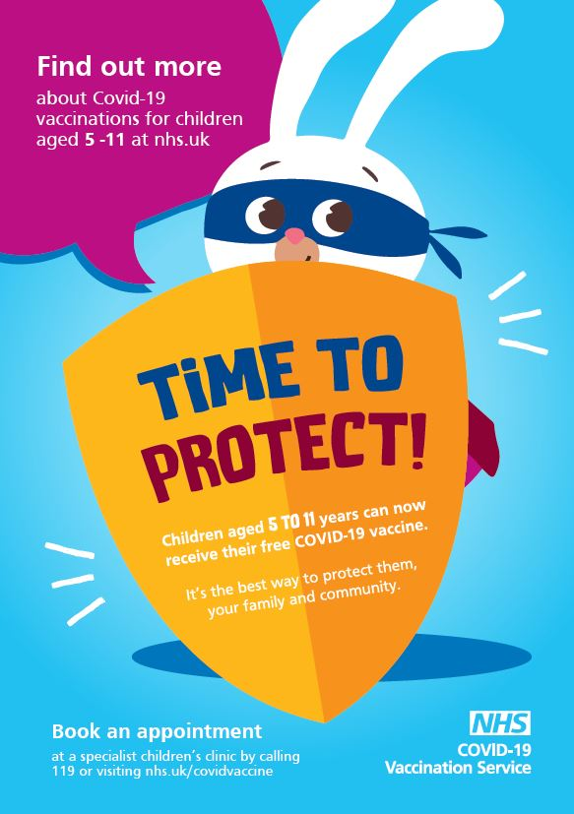
For decades, vaccinations have protected our children and young people from potentially serious diseases, including measles, flu, meningitis and mumps.
By the time they leave school, a child will typically have been offer ed vaccinations against 18 different diseases or infections – the COVID-19 vaccine is one more vaccine that children will soon be able to have to protect them from illness.
We all want to get back to normal – we want our children to go to school, do the things they love and catch up on lost time spent time with family and friends. But COVID-19 is still active and causing some children to miss out on their education and things they enjoy.
The Joint Committee on Vaccination and Immunisation recommends that 5-11 year olds be offered the vaccine, which has been approved by the UK’s medicines regulator, to boost immunity and increase their protection against any future waves of COVID-19.
The NHS in Shropshire, Telford and Wrekin wants to support families to make an informed choice, and to make things convenient and child-friendly for those who do decide to get it.
The COVID-19 vaccine is already making a big difference to help protect us all. The vaccine does not remove the virus, but research and experience in countries around the world shows it can prevent the worst effects of COVID-19 and reduce the risk of infection to your child and those around them.
From Monday 4 April, you will be able to get your child vaccinated at a site and time convenient for you – at either a vaccination centre, community pharmacy or GPs offering jabs for this age group. From Saturday 2 April you can view these sites and make an appointment through the National Booking Service or by calling 119.
Some walk-in sites are also available to vaccinate this age group. Simply check the walk-in finder website before attending to make sure they can vaccinate your child.
Children aged 5-11 with no other underlying health conditions will be offered two paediatric (child) doses of the vaccine, with at least 12 weeks between doses. A paediatric dose is smaller than doses given to those aged 12 and over.
If a child has had COVID-19 they will still get extra protection from the vaccine, but they will need to wait 12 weeks before getting vaccinated.
Those 5-11 year-olds who are more at risk from the virus can already get two paediatric (child) doses, eight weeks apart, and their GP or hospital specialist should have been in touch to arrange this, if not parents will be able book an appointment on the National Booking Service from 2 April.

To access a vaccination parents can:
- From Saturday 2 April*, book an appointment online via the National Booking System or by calling NHS 119
- Walk-in to a 5-11 year old vaccination clinic* (no appointment required): COVID-19 Vaccination Walk-in and Pop-up Clinics (stwics.org.uk)
*Please note:
- Appointments will be available from Monday 4 April
- Check clinics day & times on the day of travel as they are subject to change
Children who have recently tested positive for COVID-19:
Please note that the Joint Committee on Vaccination and Immunisation (JCVI) recommend:
- Children aged 5 to 11 years will need to wait for 12 weeks following a positive test for COVID-19 before having their first or second COVID-19 vaccination
- Children aged 5 to 11 years who are at increased risk, should wait 4 weeks (28 days) from a positive test result, before having their vaccine.
For further information:
There is more information about the COVID-19 vaccination. Resources for children aged 5 to 11 years can be found here: GOV.UK (www.gov.uk):
- COVID-19: A guide for parents of children aged 5 to 11 (publishing.service.gov.uk)
- What to expect after your child’s COVID vaccination – A guide for parents of children aged 5 to 11 years of age (publishing.service.gov.uk)
- COVID-19 vaccinations: A guide for parents of children aged 5-11 years of age at high risk (publishing.service.gov.uk)
- COVID-19 vaccination: consent form for children and young people or parents - GOV.UK (www.gov.uk)
- Frequently Asked Questions for parents of 5 to 11 year olds

