Crowmoor Primary School & Nursery
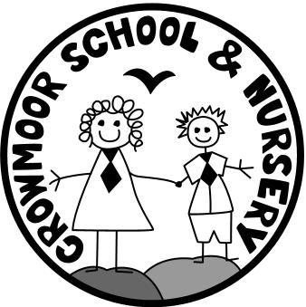
Crowmere Road
Shrewsbury
Shropshire
SY2 5JJ
Telephone: 01743 235549
Fax: 01743 243129

admin@crowmoorschool.co.uk
www.crowmoor.shropshire.sch.uk
Headteacher: Mr A J Parkhurst JP
Deputy Headteacher: Mrs J Parkhurst
School Business Manager: Miss H Cave

3rd March 2022

Dear Parents/Carers,
Easter Competition – Spring 2022

The School will be holding four competitions based on an Easter theme. The Mayor has kindly agreed to visit the School and judge the competitions, which will be held on Wednesday 6th April 2022.

The categories for the competitions are at the bottom of this letter. The competition is, as always open to all pupils and parents/carers. Please ensure that your child’s name and class are clearly marked, otherwise they cannot be judged. Entries should be made and constructed at home and must be in School on Wednesday 6th April ready for judging. All competition entries must be collected at the end of the school day on Wednesday 6th April. After this time, entries will be disposed of if uncollected.

If you have any queries, please contact the office for further information.

Yours sincerely

Jackie Clorley
School Administrator
JC/Letters/Easter/March 22

Easter Garden
This is a traditional Easter activity; a garden is made on a plate, on a tin lid, in a metal food container or on a tray. It must contain water, which represents baptism and life; spring flowers/greenery to represent growth/rebirth; a cross made from wood to show the sacrifice made by Christ; a cave or rocks to represent the tomb and sometimes eggs to show renewal and new life.

Easter Head-Gear
An existing hat or cap decorated on with an Easter theme with Easter artefacts: eggs, rabbits etc. or a totally original piece of headgear made for the occasion.

Easter - Egg Character
Make a hardboiled egg into a character dressed up e.g. a motor racing driver, a space man etc. with an appropriate name.

Easter Model/Sculpture
An Easter themed poem, piece of art, picture, sculpture, model etc.

