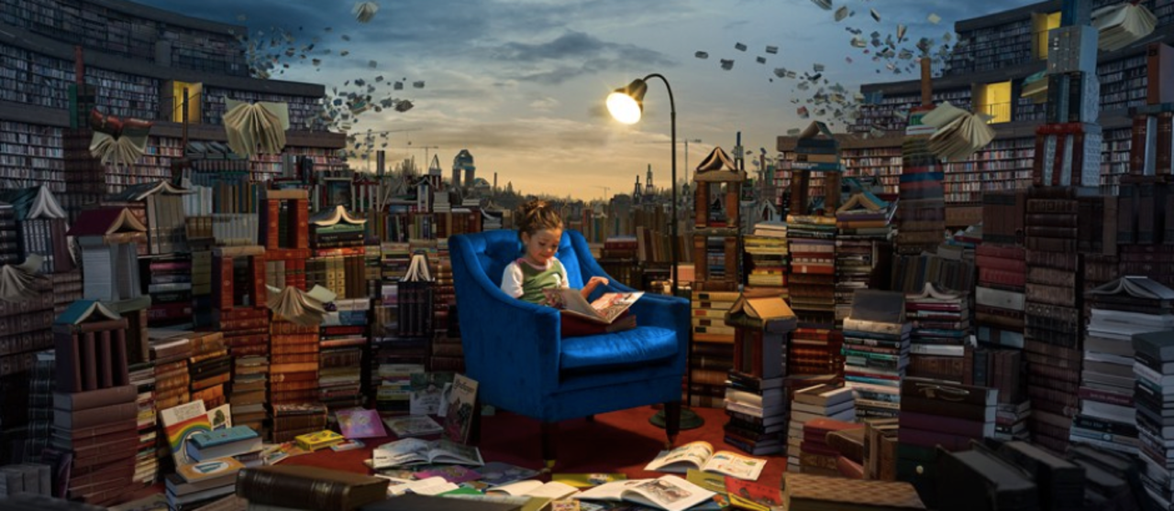
The Greatest Library

The Greatest Library

Question time!
Why do you think the little girl enjoys being in this library so much?
What book do you think she is reading?
Can you tell anything about a person by the types of books they read?
If you could write a book, what would it be about?
Which type of books would you like/not like to come alive?
If you were to take out every single book from a library would it still be a library?

Perfect picture!
Can you draw a picture of your favourite book coming alive? Think about whether it would be friendly or nasty! Will it behave like one of the main characters perhaps?

Story starter!
The books had minds of their own.
This was no ordinary library.
Books about knights and castles would gallop all over the library, bravely and boldly ordering the other books around. The books about thieves would sneak around, lurking behind bookshelves in the shadows. Books about wild animals would occasionally roar and bite other books. The ones containing stories set in the winter would often shiver, covering their neighbours with snow and frost.
Lucy loved this place like no other. Reading was the most exciting thing in the world here: everything she read seemed to come alive out of the pages…
Can you continue this story about The Greatest Library?

