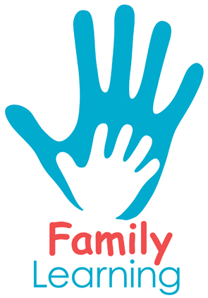
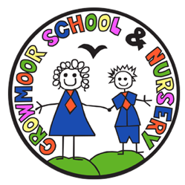

Working with Children

A FREE Family Learning course for parents and carers of children at Crowmoor Primary School
Are you interested in becoming a classroom volunteer or teaching assistant? Perhaps you would like to find out more about working in a school or childcare setting?
Join us on this free course and learn about:
- Working with primary aged children
- Understanding how children learn
- Supporting English and maths teaching
- Managing behaviour
- Emotional intelligence and developing a growth mindset
- Supporting learning difficulties
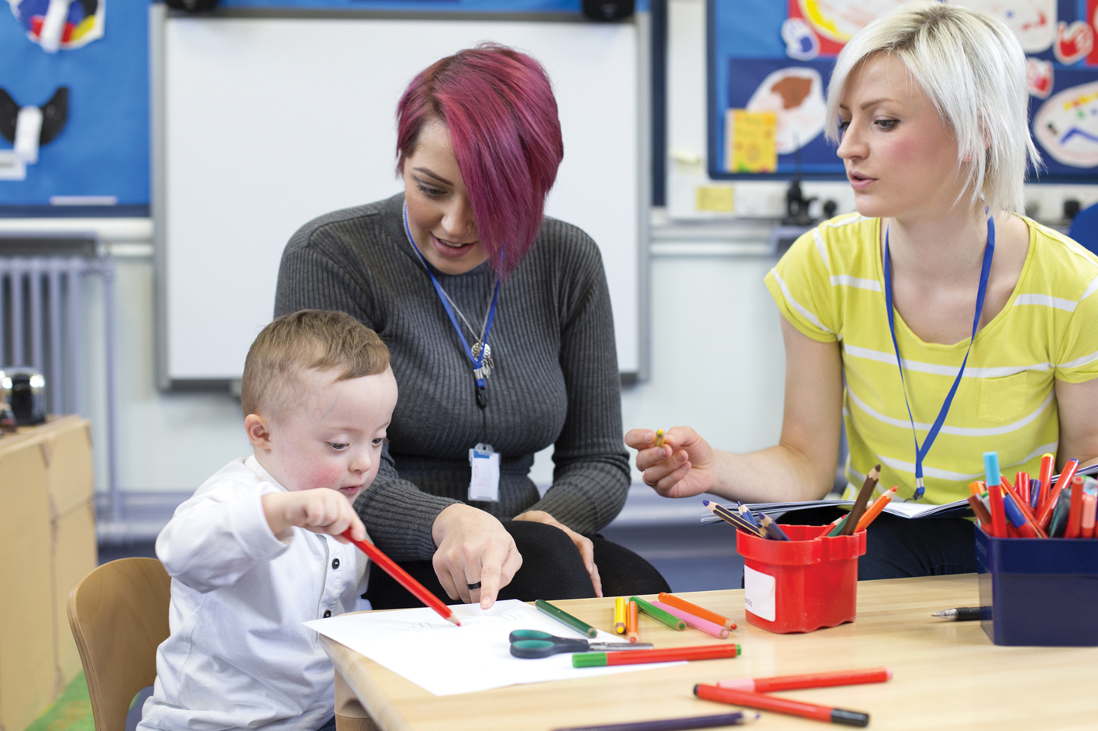
When: Tuesdays, 10 sessions starting on 5th October, 1.00 - 2.30pm
Where: Crowmoor Baptist Church

To book your place on this free course please contact the school office on 01743 235549 or email admin@crowmoorschool.co.uk and leave your name and contact number.
Facebook.com/FamilyLearningShropshire

