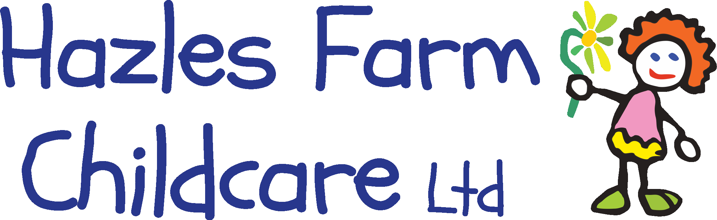
Crowmoor Nursery and Preschool
Crowmere Road,
Shrewsbury.
SY25JJ
07908704532
Crowmoor.hfcc@gmail.com

We are excited to announce working in partnership with Shropshire Council and Crowmoor School, we are please to be able to offer sessions to all children in Shropshire who receive benefits related Free School Meals aged 5 yrs. – 11yrs. You will be eligible to attend our holiday programme free of charge from week commencing 2nd August – 27th August. Each child is entitled to 16 free hours per week where a healthy snack and nutritious lunch will be provided alongside fun physical planned activities using the outdoor facilities at Crowmoor School.
The session time is 10:00am to 2:00pm Monday to Friday, 2nd August – 27th August.

Please see below for our Holiday activities available.

If you would like to book a place for your child, please contact the nursery on 07908704532 or crowmoor.hfcc@gmail.com where we will happily check your eligibility and talk you through the process. Forms can be collected from either Crowmoor school or Crowmoor nursery at the Little Acorns gate.

If you have any further questions please do not hesitate to contact Amy or Julie directly at the nursery.

We look forward to seeing you during the Summer.

Amy Beard
Nursery Manager
Sports Week
Monday 2nd August | Tuesday 3rd August | Wednesday 4th August | Thursday 5th August | Friday 6th August
Mini golf | Soft play | Football fun | Basket ball | Sports day
Healthy Eating
Monday 9th August | Tuesday 10th August | Wednesday 11th August | Thursday 12th August | Friday 13th August
Decorate your own eat well plate | Taste test | Make your own smoothies | Funky fruit patterns | Make your own healthy pizzas
Outdoor environment
Monday 16th August | Tuesday 17th August | Wednesday 18th August | Thursday 19th August | Friday 20th August
Forest fun | Bug hunt | Outdoor den building | Flower suncatchers | Outdoor obstacle course
Games week
Monday 23rd August | Tuesday 24th August | Wednesday 25th August | Thursday 26th August | Friday 27th August
Board game competition | Connect 4 | Quiz day! | Twister | End of summer party
Summer Holiday activity Programme

