History (The Mayans)  Article 29 - Education must develop every child’s personality, talents and abilities to the full.  Our topic will investigate the following areas in detail:  - Who were the Mayans?  - Mayan Religion and Gods  - The Mayan Number System  - The European Discovery of the Mayans  - The Mayan Writing System  - Mayan Foods  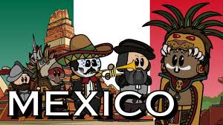 | Science  Article 12 - Every child has the right to have a say in all matters affecting them, and to have their views taken seriously.  - Animals including humans – we will learn about the circulatory system and how our body transports water and nutrients. We will look at the importance of a healthy lifestyle and exercise and the negative effects alcohol and drugs can have on our well-being and overall health  - In the second Half of the Term we will continue with our ‘Respect Yourself’ program – this is the school and Local Authority Sex and Relationship Education program and content will be an extension of that taught in previous years |  |  |  |  |  | Geography  Article 20 – Governments should ensure children are looked ager and that they are take into account the child’s religion, culture and language.  We cannot talk about the Mayans without giving the children a really good geographical sense of what America is like so we will:  - Look at the Countries and the Continents  - Look at locations within America  - Look at the Weather and climate of America  - Spend some time comparing America to the UK  We will then investigate Rivers:  - Where water comes from  - The main Rivers of the World  - The features of a River  - Erosion and Deposition  - How we use Rivers  - The effects of Flooding
 | Literacy
 | Writing Opportunities | Narrative Influences |  | Non-Fiction |  | Communication
 | We will start the term by completing our Study of Quests/legends and will conclude it by writing a Quest linked to our previous Anglo-Saxon historical study | We will study ‘The Piano’ – it is a short clip about an old man playing the piano and having flashbacks of important points in his life. We will then create a flashback of our own in the style of ‘The Piano’ influence.  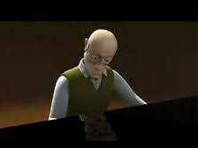 |  | Persuasion: We will learn the conventions of a debate and debate concerns the children have about issues in the World. |  | If we can go to Arthog the children will experience how to communicate in a real life scenario and how communication helps teams develop and problem solve.
French  Article 30 - Every child has the right to learn and use the language.  - Naming parts of the body  - Looking at French Nursery Rhymes  - Naming Zoo animals  - Recognising letters in the alphabet  - Recognising vowel sounds  - Communication games  - Singing French songs | ‘The Mayans – A Mexican Study’  Article 28 - Every child has the right to an education. |  |  |  |  |  | Computing  Article 16 - Every child has the right to privacy.  - Programming using Kodu and Espresso Coding  - Learning about technology and its impact on our life  - Using the internet to help research topic work  - Learning more about online safety and keeping safe
 | Topic Starter  The children need to understand the location of Mexico in relation to the UK and the rest of Northern America – as such we will study a cross-curricular geographical unit in tandem with our Mexican study. |  | Local Link  We hope to visit the Abbey later in the term. We had planned to go last term but visits were not recommended. We will link the visit to our RE theme after Half Term.  https://www.shrewsburyabbey.com |  | Fab Finish  We hope to invite ‘The Animal Man’ into school to complete our Central America topic. He will show the children animals you would find in the region we have studied.

Art  Article 31 - Every child has the right to relax.  Mexican art is vibrant and colourful. They mainly use primary colours and create prints of pattern and complimenting shapes. We will study artefacts and try and create our own versions artistically. We will also try and print using the block printing method.  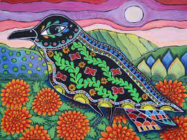 | Maths  Article 29 - Education must develop every child’s personality, talents and abilities to the full.  We start the term looking at some of the areas the children looked at Lockdown but struggled on. We start the term continuing our Algebra themed unit. We then progress onto Measures, Areas and Perimeter and Volume. Some areas we cover this term are specific to Y6 and whilst the Oaks Academy hinted at how to use the skill I feel we need to spend some dedicated time learning them together in class.  In the second Half of the Term we progress to Ratio and Proportion, Data Handling and looking at Angles. With the cancellation of SATs we have the luxury of teaching the content all the way until July. Normally the children would have had to have had the content delivered prior to SATs in May. This is particularly useful this year as the first term of Y6 was spent looking at the content the children missed when they were in the first lockdown (March to July last year when they were in Y5). |  | PE  Article 24 - Every child has the right to the best possible health.  The weather is improving and we need to take advantage of this. Over the next term we will play Cricket, Rounders and complete in Athletic events.  Where possible the children will compete against other schools (Rounders and Cross Country).  Please ensure your child has their PE kit on ready to partake in the lesson on a Wednesday and dates when our Coach is in (dates to be advised).
D&T  Article 7 - Every child has the right to be cared for by their parents.  When we look at Mexican/Mayan Food in history, we attempt to make fajitas with Mexican influences and ingredients.  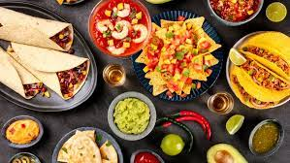 | RE  Article 14 - Every child has the right to think and believe what they want and to practise their religion, as long as they are not stopping other people from enjoying their rights  In the first Half of the Term we will look at how religions value Peace. We will look at the value of Community Cohesion and we will investigate and design symbols for Peace.  In the second Half of the Term we will visit ‘The Abbey’ – we will spend some time before the visit studying the history of the building and its importance for Shrewsbury.  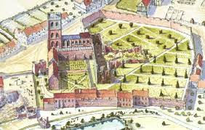 | PSHE  Article 17 - Every child has the right to reliable information from the media.  Continuing our theme of Health and Wellbeing we will start the term linking our PSHE to our Science topic. The children will learn that their body is their own, the importance of exercise and sleep, how to take care of their bodies and how to avoid harmful substances. They will also articulate feelings about their bodies and learn about healthy choices. This unit is particularly important prior to the children progressing to Secondary school.  In the later part of the year we will continue our school and LA Recommended ‘Sex and Relationship Education’ Program.  The children have limited time left in Primary school, some of the term will be spent looking at the transition from Primary to Secondary. | Music  Article 31 - Every child has the right to relax, play and take part in a wide range of cultural and artistic activities.  It is hoped that we will conduct our normal End of Year play in July – if COVID Regulations allow. This will probably be related to a theme from the year and will consist of acting , dancing and singing. The play, I have in mind, has fantastic songs and possibilities for instrumental accompaniment.

