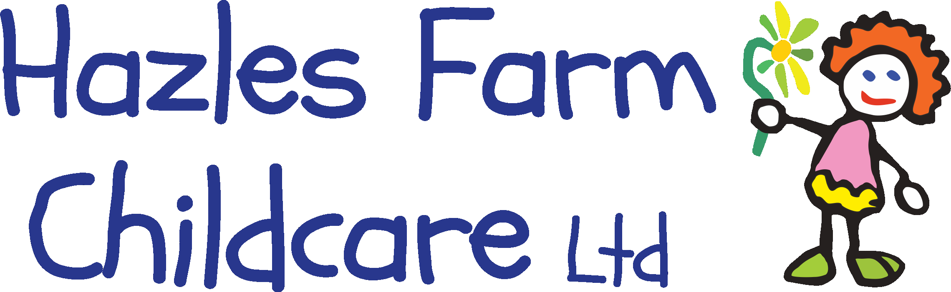
Crowmoor Nursery and Preschool
Crowmere Road,
Shrewsbury.
SY25JJ
07908704532
Crowmoor.hfcc@gmail.com

We are excited to announce working in partnership with Shropshire Council and Crowmoor School, we are please to be able to offer sessions to children from Reception to Year 2 during the Easter holidays. Each child is entitled to 16 free hours per week where a health breakfast, a nutritional lunch and a morning snack will be provided alongside fun physical planned activities using the outdoor facilities at Crowmoor School.
The session time is 8:30am to 12:30pm Tuesday 6th April 21 to Friday 9th April 21.

Please see below for Easter Holiday activities available.

If you would like to book a place for your child please contact the nursery on 07908704532 or crowmoor.hfcc@gmail.com where we will happily talk you through the process. Forms can be collected from either Crowmoor school or Crowmoor nursery at the Little Acorns gate.

If you have any further questions please do not hesitate to contact Amy or Julie directly at the nursery.

We look forward to seeing you at Easter.

Amy Beard
Nursery Manager

Monday 5th April | Tuesday 6th April | Wednesday 7th April | Thursday 8th April | Friday 9th April
Closed due to Bank Holiday | Easter Egg hunt in forest school | Egg and spoon races | Ball games on the sports court | Soft Play
Easter Holiday Activities at Crowmoor Nursery and Holiday club.

