Hi everyone,

The answers for this last week’s homework are as follows:

Grammar:

Spelling:

Punctuation:

Arithmetic:

Geometry…:

Number:

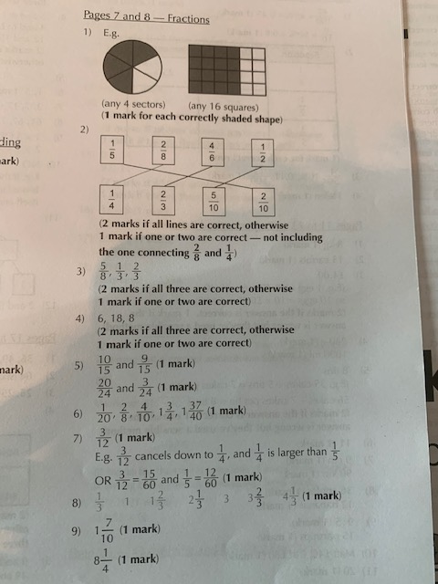

New homework set on the ‘NEWS’ part of our class webpage.

Have a good weekend.

Mr Wilmot