Crowmoor Primary School & Nursery
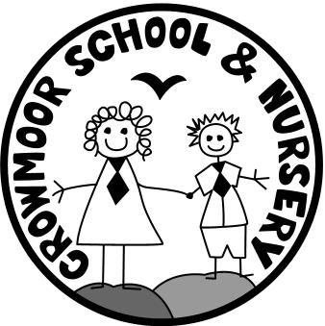
Crowmere Road
Shrewsbury
Shropshire
SY2 5JJ
Telephone: 01743 235549
Fax: 01743 243129

admin@crowmoorschool.co.uk
www.crowmoorschool.co.uk
Headteacher: Mr A J Parkhurst JP
Deputy Headteacher: Mrs J Parkhurst
School Business Manager: Miss H Cave

7th January 2021

Dear Parent/Carer,

I am writing to you regarding Microsoft TEAMS. We propose to use TEAMS to interact with your child on a weekly basis. More information on how this will work will be sent to you by your child’s Class Teacher.

Due to our bandwidth in school, the classes will be split into groups for a weekly video chat.

During specified lesson times we will use the chat function to communicate and support pupils.

We have already requested that you provide us with an up to date email if this isn’t already on our system. If you have not yet done this please contact the school office, by the end of the week.

You will receive a TEAMS invite from your child’s Class Teacher inviting you to join a session. Once you receive this please follow the steps below:
- Check your email for the TEAMS Meeting invite and click the Join Microsoft Teams Meeting link.
- Open TEAMS on the web or download the program
- Enter your name and choose your audio and video settings
- Click the Join Now button to be admitted into the meeting
- Finally, you’ll be put into the meeting lobby. Once you’re in the lobby, the meeting organiser will be notified that you’re there, and you’ll be admitted in. If no one has admitted you to the meeting within 15 minutes of joining, you’ll be kicked out from the lobby, and you’ll need to join again.
Please note we hold no responsibility for use of the TEAMS. This is powered through Microsoft. We maintain the security while using the app in school. However, you are responsible for ensuring internet security, while you are using the app with your child at home. We also advise that all internet usage is supervised by an adult.
If you have any queries regarding this, please do not hesitate to contact the school office.
Yours sincerely

Miss H Cave
School Business Manager

