Crowmoor Primary School & Nursery
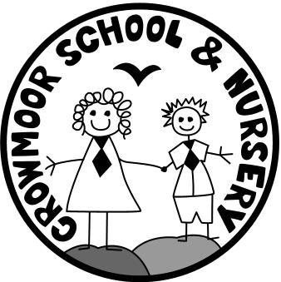
Crowmere Road
Shrewsbury
Shropshire
SY2 5JJ
Telephone: 01743 235549
Fax: 01743 243129

admin@crowmoorschool.co.uk
www.crowmoorschool.co.uk
Headteacher: Mr A J Parkhurst JP
Deputy Headteacher: Mrs J Parkhurst
School Business Manager: Miss H Cave

1st December 2020.

Dear Parents and Carers,

Christmas Lunch – Friday 11th December 2020

Christmas is fast approaching and we are pleased to be able to let you know the details of the Christmas Lunch planned for this year.

The menu is a traditional Christmas turkey dinner with a Vegetarian option.

Unless your child is eligible for free school meals, the cost of the lunch will be £2.30 and needs to be paid on the day. Please return the reply slip below even if your child is entitled to a free school meal or does not want a Christmas dinner.

There will be a change of menu on Wednesday 9th from roast dinner to a pizza day and this will allow for the traditional Christmas roast on Friday 11th.

Friday 11th December will also be a bright coloured clothes day for the children and School uniform will not need to be worn.

Reply slips need to be returned by Friday 4th December 2020.

Yours Sincerely

Mrs N Preston - Administrator

I confirm that my child ____________________________in Class ___________ would like Roast Christmas Dinner on Friday 11th December and that I will make a payment of £2.30 on the day.

Vegetarian option required

My Child does not want a Christmas Dinner

