Crowmoor Primary School & Nursery
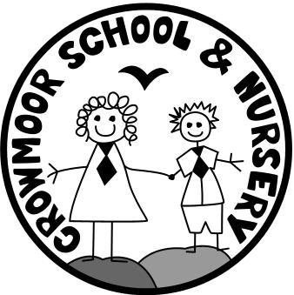
Crowmere Road
Shrewsbury
Shropshire
SY2 5JJ
Telephone: 01743 235549
Fax: 01743 243129

admin@crowmoorschool.co.uk
www.crowmoorschool.co.uk
Headteacher: Mr A J Parkhurst JP
Deputy Headteacher: Mrs J Parkhurst
School Business Manager: Miss H Cave

5th November 2020

Dear Parents/Carers,

As we enter another period of National Lock-down I thought it important to state the simple things we can do to keep everyone linked to Crowmoor as safe and well as possible.

This is a frightening time for all of us but especially for children. If your child is concerned about the virus and you would like us to talk to them and offer reassurance then please let the Class Teacher know by contacting the office.

Masks
We are very grateful to everyone for wearing a mask to ensure everyone is as safe as possible.

Dropping Off and Collection of Pupils
Please remember only 1 adult per family is allowed on the school site at the beginning or end of the school day to minimise possible contacts between households.

Appropriate Clothing
As we move into Winter we have turned the heating up to full blast! But with the government saying that windows have to be kept open to ensure proper ventilation it is going to get cold in the classes. Children should wear plenty of thin layers to keep as warm as possible. An example of layers might be to wear a T-shirt/vest and then a shirt/blouse, a jumper/sweatshirt or hoody and always a coat. Hats and scarfs are allowed too.
Having the children come to school in PE kit on their PE days has been a great success, no child is now missing PE because of forgetting their PE gear. But please remember to dress them up in layers: track suit bottoms or jog pants and lots of tops along with their coat, as it will be too cold to be outside or inside schooI in just PE kit. If you are in any doubt about when PE is for your child please check the Class website or ring the Office.

A Positive Test/symptoms
We have had a number of parents who have had positive results. When this happens you will then self-isolate for 10 days and your children for 14 days. If your child has any symptoms, however slight after you have a positive diagnosis they are eligible for a test. Any family testing positive obviously causes anxiety for
the parents of other children in that class and also the adults in school, who have been in very close contact with the children. A test result will enable them to be less anxious.

If you are in any doubt about your child having one of the main symptoms: a dry continuous cough, a temperature or loss of sense of smell/taste please keep them at home and organise a test. If we detect any of the symptoms at school we will have to send a child home to self -isolate for 10 days.

Always Stay 2 Metres Apart
With the infection rate increasing we must strongly request that all parents maintain 2 metres social distancing whilst on school premises. In order to protect the safety of everyone else we will warn parents who are not observing proper social distancing. If they then do not comply, they will not be allowed on the school site.

Please remember:
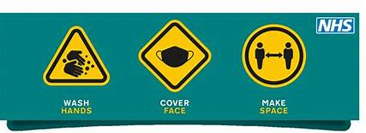

Yours sincerely

Mr A J Parkhurst
Headteacher

