Crowmoor Primary School & Nursery
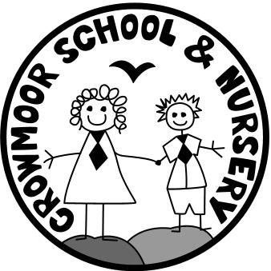
Crowmere Road
Shrewsbury
Shropshire
SY2 5JJ
Telephone: 01743 235549
Fax: 01743 243129

admin@crowmoorschool.co.uk
www.crowmoorschool.co.uk
Headteacher: Mr A J Parkhurst JP
Deputy Headteacher: Mrs J Parkhurst
School Business Manager: Miss H Cave

Thursday 15th October 2020

Face Masks
Dear Parents/Carers,
With the increasing infection rate of Covid-19 across the country and the announcement of further measures to combat this by the government this week, we have reviewed our safety measures and would hope that all of you will support our renewed efforts to keep you and your children safe whilst on the School site.
It is clear from the figures that education settings are providing one of the biggest areas of virus outbreaks, and you will have seen the closure of local schools over the last few weeks.
We don’t want Crowmoor to be one of those schools!
2 metres social distancing is not easy and on most days is difficult to maintain.
In order to protect others, from Monday 19th October we request that all adults coming onto the school site wear a face covering. This means face coverings must be worn on the playground when dropping off in the morning and collecting from School in the afternoon. And at any other time when accessing the School site.
If you have a valid reason not to wear a face mask please either download an exemption badge from www.assets.publishing.service.gov.uk. Or, wear a sunflower lanyard and badge from Hidden Disabilities www.hiddendisabilitiesstore.com.
If you cannot wear a mask it is vital you keep the 2 metres distance.
We thank you in advance for helping us to keep all of our school community safe.
Yours Sincerely,

Mr A. J. Parkhurst

