Crowmoor Primary School & Nursery
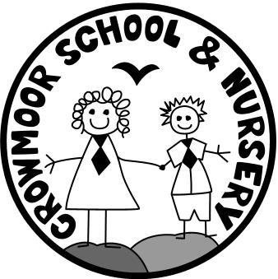
Crowmere Road
Shrewsbury
Shropshire
SY2 5JJ
Telephone: 01743 235549
Fax: 01743 243129

admin@crowmoorschool.co.uk
www.crowmoorschool.co.uk
Headteacher: Mr A J Parkhurst JP
Deputy Headteacher: Mrs J Parkhurst
School Business Manager: Miss H Cave

28th September 2020

Dear Parents and Carers,
Following on from the information we gave out at the induction session in July, we would like to confirm that Crowmoor has been accepted by the DFE as an early adopter school and give you information about how this impacts on the assessment framework at Crowmoor for the Early Years Foundation Stage (EYFS) .
The EYFS is guided by a framework called ‘Development Matters’ that sets out the learning and development expectations for all children until the end of their Reception year. At the end of the year, your child is assessed against 17 Early Learning Goals in the 7 areas of learning.
The Early Learning Goals have been updated and the Development Matters guidance has also been reviewed. Although not statutory until September 2021, all schools were offered the opportunity to be an ‘Early Adopter’ of these new reforms.
At Crowmoor Primary we are always keen to be involved early in positive changes in education and we are excited to have been selected to become an ‘early adopter’ school, before the statutory implementation begins for all schools in September 2021.
The reforms bring about some exciting changes and if you have had a child who has been in Reception in recent years, things may look a little different this year on Tapestry or when you receive their final reports but nothing will change for the children. Miss Jones will continue to offer them the highest quality learning experiences in school and will continue to develop the whole child, thinking about how they learn and who they are as individuals. The EYFS framework has never prescribed a particular teaching approach and the new framework holds true to this value. Our philosophy of early year’s education remains the same with play and wellbeing at the heart of everything we do.
You can find a document detailing the new ELGs and a link to the detailed ‘EYFS Early adopter Framework - Development Matters’ document by visiting the Beech Class information page: http://crowmoorschool.co.uk/home/parents-area/classes/beechclass-information/
In the final term of the year, a profile will be completed for your child, as it always has been, providing a rounded picture of a child’s knowledge, understanding and abilities, their attainment against expected levels, and their readiness for Year 1. Throughout their year in Reception, the children will continue to be observed and assessed through their play in order to gain insights and make reasonable judgements against the Early Learning Goals. The main difference this year is that we will use the terms ‘Emerging’ or ‘Expected’ to describe our judgements as under the new guidance the term ‘Exceeding’ has been removed.
We hope that this letter has provided some detail regarding what it means to be part of this early adopter year, but if you have any questions, please do not hesitate to contact Miss Jones.
Yours sincerely,

Mr A J Parkhurst
Headteacher

