Crowmoor Primary School & Nursery
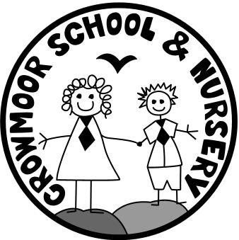
Crowmere Road
Shrewsbury
Shropshire
SY2 5JJ
Telephone: 01743 235549
Fax: 01743 243129

admin@crowmoorschool.co.uk
www.crowmoorschool.co.uk
Headteacher: Mr A J Parkhurst JP
Deputy Headteacher: Mrs J Parkhurst
School Business Manager: Miss H Cave

2nd July 2020

Year 6 Leavers Assembly 2020

Dear Parents/Carers,

We are planning to hold a socially distanced Year 6 Leaver’s Assembly on the afternoon of Thursday 9th July.
This will be for children only and will be held outside in the School grounds.

At this time, the children will receive their reports, their leavers hoodie and their School books. It is also an opportunity for your child to return their locker key if they haven’t already done so.

Year 6 children who are not already in on that day will need to arrive at 1.15pm and line up on the path, socially distanced on the two metre markers. They will be met by a member of staff who will escort the children around to the back of the School.

The children currently working from home will need to complete their Crowmoor Memories piece of writing to share with the rest of the Class at the assembly. A guide for this will be included on their new fortnightly work that will be on the website from Friday 3rd July.

The children that have come into School especially for the assembly can be collected at 2.45pm or will be able to walk home. The children already in School will return to Class and will finish School at their normal time.

It may become necessary to cancel or re-arrange the assembly due to bad weather.

Any further questions, please contact the office.

Yours Sincerely,

Mrs N Preston.
Administrator.

