Animal Characteristics
Match the descriptions of characteristics with the correct group of animals…
Mammals
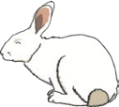
Birds
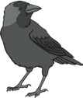
Fish
Reptiles
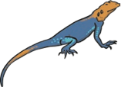
Amphibians
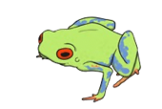
Insects
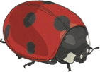
Arachnids
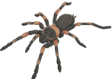
Annelids
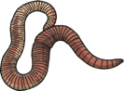
Molluscs
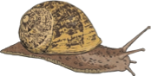

Crustaceans
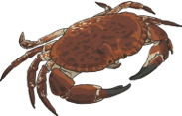
Echinoderms
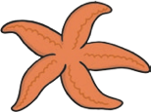
Science | Year 6 | Living Things and Their Habitats | Curious Creatures | Lesson 3

Cut the descriptions of characteristics below into strips then match them with the correct group of animals…
These animals have hard, scaly skin, and are cold blooded. They use lungs to breathe air and they lay their eggs on land.
Most of these cold blooded animals have a soft body covered by a hard shell. Some live on land, and move slowly on a flat sole called a foot. Others live in water and attach themselves to rocks or other surfaces.
These animals live on land or in water. They are cold blooded. They use gills to breathe when they are young, and use lungs to breathe when they are adults. They have moist, smooth skin and have 4 legs. They lay eggs in water.
These animals have 2 legs and a beak. They have feathers and wings. Some can fly, while others can’t. They lay eggs on land. They are warm blooded.
Most of these animals have 4 pairs of legs. The front pair of legs may be used for holding their prey and feeding. They have a hard exoskeleton and jointed legs for walking. They do not have antennae. They are cold blooded.
These animals have an exoskeleton covering their body. Their body is made from 3 parts: the head, the thorax and the abdomen. They have a pair of antennae on their head. They are cold blooded.
These creatures have scaly skin and live in water. They use gills to breathe. They have fins. They lay their eggs in water, and they are cold blooded.
These are marine creatures, which means they live in the ocean. They have arms or spines that radiate from the centre of their body. The central body contains their organs and their mouth. They are cold blooded.
These creatures do not have any limbs. Their body is divided into segments. Some of them have bristles on their skin, while others have very small bristles and their skin seems smooth. They are cold blooded.
These creatures have hair or fur. They breathe air through lungs. They feed milk to their young. They are warm blooded.
These creatures have a hard external shell that protects their body. They have a head and abdomen. Many of these animals have claws that help them with crawling and eating. They are cold blooded.

