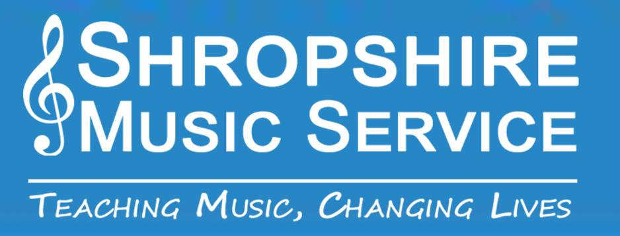

Shropshire Music Service
Online Lessons - Instructions for Parents and Carers
If you wish your child to have online lessons from Shropshire Music Service:
Please send an email containing the following to admin@shropshiremusicservice.org.uk.
- Your name
- Child’s Name
- Instrument
- School
- Instrumental teacher
We will ask the child’s instrumental teacher to contact you via your email address to confirm the time and day of the lesson (it is envisaged that the lesson will take place at the same time each week).
Please download ‘Zoom’ onto your chosen device using the same email address to sign up.
The teacher will then schedule the lesson and you will receive an ‘invitation via email.
Lessons will be covered by the standard SMS terms and conditions on the Shropshire Music Service Website

