Crowmoor Primary School & Nursery
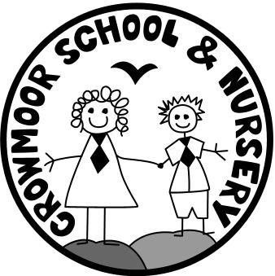
Crowmere Road
Shrewsbury
Shropshire
SY2 5JJ
Telephone: 01743 235549
Fax: 01743 243129

admin@crowmoorschool.co.uk
www.crowmoor.shropshire.sch.uk
Headteacher: Mr A J Parkhurst JP
Deputy Headteacher: Mrs J Parkhurst
School Business Manager: Miss H Cave

28th April 2020

Dear Parents/Carers,

Year 6 Leavers Hoodies

We would like the Year 6 pupils to have the opportunity to order a Leavers Hoodie as a memento of their time at Crowmoor School. They are standard hoodies, which will have a number ‘20’ printed on the back, made up of the children’s names. They come in a range of different colours that your child be able to choose. We would like a first and a second choice of colour, in case there is a supply issue.

School will fund the cost of the hoodie.

Please can you contact the School by Monday 4th May with your child’s first and second choice of colour and the required size.
This can be done by email on admin@crowmoorschool.co.uk or telephone 01743 235549 between 9am and 3pm

The colour chart is attached and the sizes are age 9-11 (32 inches), age 12-13 (34 inches), extra small adult (36 inches) or small adult (38 inches)

If you require further information, please contact the office.

Yours sincerely

Mrs N Preston
Administrator

