Countries of Europe
Find and circle all of the Countries of Europe that are hidden in the grid.
The remaining letters spell a secret message.
Note: IRELAND and NORTHERN IRELAND are separately hidden and do not overlap.
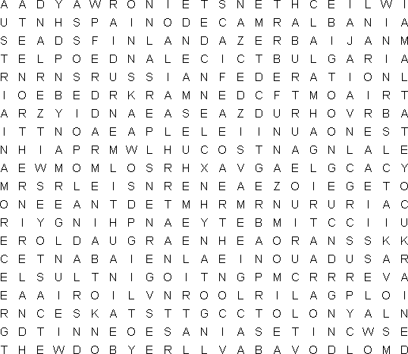
ALBANIA  ANDORRA  ARMENIA  AUSTRIA  AZERBAIJAN  BELARUS  BELGIUM  BOSNIA-HERZEGOVINA  BULGARIA  CROATIA  CYPRUS  CZECH REPUBLIC  DENMARK |  | ENGLAND  ESTONIA  FINLAND  FRANCE  GEORGIA  GERMANY  GREECE  HUNGARY  ICELAND  IRELAND  ITALY  LATVIA  LIECHTENSTEIN |  | LITHUANIA  LUXEMBOURG  MACEDONIA  MALTA  MOLDOVA  MONACO  NETHERLANDS  NORTHERN IRELAND  NORWAY  POLAND  PORTUGAL  ROMANIA  RUSSIAN FEDERATION |  | SAN MARINO  SCOTLAND  SLOVAKIA  SLOVENIA  SPAIN  SWEDEN  SWITZERLAND  TURKEY  UKRAINE  SERBIA/MONTENEGRO  VATICAN CITY  WALES

