Computer Jargon 2
Find and circle all of the computer words that are hidden in the grid.
The remaining letters spell an additional computer word.
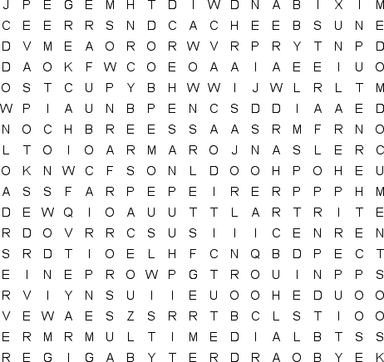
ASCII  BANDWIDTH  BIOS  BUG  CACHE  CHIP  COPY  CPU  CRASH  CYBERSPACE  DATABASE  DESKTOP |  | DISK  DOCUMENT  DOWNLOAD  DRIVER  EMOTICON  ETHERNET  FAQ  FIREWIRE  FONT  FREEWARE  GIGABYTE  HACKER |  | HARDWARE  INPUT  JAVA  JPEG  KEYBOARD  LINUX  MENU  MODEM  MULTIMEDIA  NETIQUETTE  OPEN |  | PASSWORD  PCI  PERIPHERAL  PORT  PRINTER  REBOOT  RESOLUTION  SAVE  SCROLL  SERVER  SMILEY |  | SOUNDCARD  SPYWARE  TERAFLOP  TROJAN HORSE  UPLOAD  USB  USERNAME  VIRUS  WEB BROWSER  WINDOWS  ZIP FILE

