Computer Jargon 1
Find and circle all of the computer words that are hidden in the grid.
The remaining letters spell an additional word.
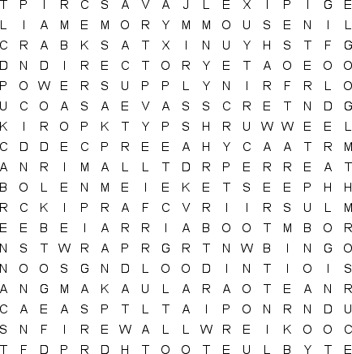
APPLICATION  BACKUP  BINARY  BLUETOOTH  BOOT  BYTE  CHAT  CLICK  COOKIE  CURSOR  DATA |  | DEFRAGMENT  DIRECTORY  DISK DRIVE  DOS  DRAG  EMAIL  ENCRYPTION  FILE  FIREWALL  FOLDER  GIF |  | GOOGLE  HTML  ICON  INTERNET  JAVASCRIPT  KERNAL  LCD  LOGIN  MEMORY  MONITOR  MOUSE |  | NANOSECOND  NETWORK  PARTITION  PASTE  PDF  PIXEL  POWER SUPPLY  PROGRAMMER  ROUTER  SAVE AS |  | SCANNER  SECURITY  SHAREWARE  SOFTWARE  SPAM  TASKBAR  THUMBNAIL  UNIX  WALLPAPER  WIRELESS

