Crowmoor Primary School & Nursery
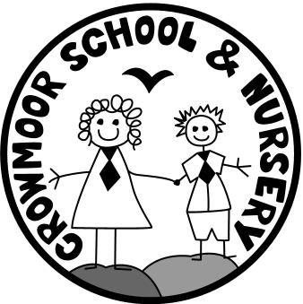
Crowmere Road
Shrewsbury
Shropshire
SY2 5JJ
Telephone: 01743 235549
Fax: 01743 243129

admin@crowmoorschool.co.uk
www.crowmoor.shropshire.sch.uk
Headteacher: Mr A J Parkhurst JP
Deputy Headteacher: Mrs J Parkhurst
School Business Manager: Miss H Cave

16th March 2020
COVID-19 Update

Dear Parents/Carers,
We are writing to update you regarding the current COVID-19 situation and how it impacts on the School.
We will always act in the best interests of all the pupils and do our utmost to ensure their well-being and safety. We have changed the way children come into school, they no longer line up but will come straight into school. All children will sanitise their hands on arrival and before they go home. Please can you ensure, as the government has asked, that your children wash their hands before leaving home.
To minimise the risk of infection to children and staff, no visitors/parents will be allowed into the school building until further notice. If you wish to speak to staff you must do this via telephone/email.
No meetings will be organised or held at school, if parents require information or wish to discuss anything regarding their child please can you email or phone:
admin@crowmoorschool.co.uk 01743 235549

(Please be aware that emails are not constantly monitored therefore, if you need to get an urgent message to the school office please telephone.)

All school events to be held on school premises will be postponed until a future date. We will notify you of these changes when we have further information.
The Governments strong advice at the moment is that schools are not to shut, apart from a deep clean. If this advice changes, initially the children will be given work on paper outlining tasks that they will need to complete. In the following weeks further work will be available on the class website pages.
In order to minimise the risk of spreading the virus if any child shows any of the symptoms which are: shortness of breath, new dry cough, temperature, or any symptoms of cold or flu, we will ring you to request you immediately take your child home to self-isolate. Therefore, please ensure we have up to date contact details and that we have a second named person ready to contact.
As you are well aware things are changing on a daily basis so we thank you for your co-operation, we will update you as and when we have further information.
Yours Sincerely,

Mr A J Parkhurst - Headteacher.

