History  Article 17: Every child has the right to reliable information.  As historians we will…research and find out about:  - The Space race– we will make a timeline of journeys to space  - We will choose a key figure from the space race e.g. Neil Armstrong, Buzz Aldrin and Yuri Gagarin and complete “talk” for our peers. | Science  Article 29: education should teach children to respect their natural environment. Education must teach children to live responsibly encourage the child’s respect for the environment.  As scientists we will…  Learn about The Earth and Space  - We will know what causes night and day: we will know that the Earth rotates on its axis, that we have different time zones and why we have different seasons.  - We will know about the length of a year: how the Earth orbits the Sun  - We will know about the different phases of the Moon: we will know how the Moon’s gravity causes high and low tides. Moon:  - We will know what the Solar System is.  - We will be able to describe the Sun, the Earth and the Moon. |  |  |  |  |  |  | Geography  Article 1: Everyone under the age of 18 has rights (Children should learn that all children everywhere have the same rights).  Article 7: Every child has the right to a nationality.  Article 29: education should teach children to respect their natural environment. Education must teach children to live responsibly encourage the child’s respect for the environment.  As geographers we will…  - research and plot the different launch and landing sites around the world  - find out about different countries that have space programmes—which have launch capability?  - Know what nationalities are represented in the International Space Centre? How do they effectively communicate with each other?
Literacy – Class Novel:
As readers we will… read
“The Wizards of Once.”
We will also take part in the Shrewsbury Book Festival: We have six books to read before we meet the authors at Theatre Severn.
French
As learners of French we will sing and speak about…
- What we like/don’t like (eg: foods),
- un/une & adjective agreement,
- describe objects acc to colour & number,
- Life in a French school,
- words we share,
- Easter traditions in France.
 | Out of This World
 | Super Start:  To launch this theme we will enter “The Wonder Dome!” |  | Local Link:  To engage the children further the children will take part in a scientific analysis where they will investigate the following:  Aliens crash land in school grounds.  The children will analyse the scene and evidence found.  Presenting a documentary to record their conclusions. |  |  | Fab Finish:  The children will organise a mission to Mars:  They will hold an official launch day of rockets built by children.  The children are to dress up as astronauts and launch their rocket models after a day of preparation where they will decide what necessities they will need for their journey into space.
PE
Article 6: every child has the right to life. Governments must do all they can to make sure children survive.
Article 23: A child with a disability has the right to live a full decent life and play an active part in the community. Governments must do all they can to provide support for disabled children.
Article 24: every child has the right to good health.
As gymnasts we will…
Learn, practice and polish our skills so that we can perform gymnastic moves and sequences.
As dancers we will…
Learn, practice and present a dance sequence to music.

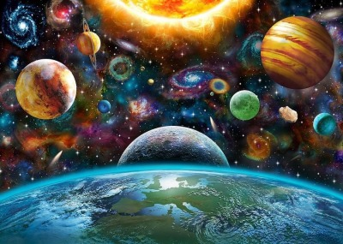
Art
Article 29: Education must develop every child’s personality, talents and abilities to the full.
As artists we will…
- Use multi mixed media to decorate our “Shoe-Box” theatres: colour, tone, tint and texture.
- Use other artists work to create our own Space landscapes using mixed media: paint, chalk and inks.

 | Narrative Influences | Non-Fiction |  |  | Poetry |  | Communication
 | As writers we will…  Write a play script for our “Shoe-Box” theatres.  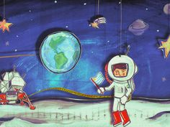  Write a sci-fi adventure narrative. | As writers we will…  Write a newspaper report about Tim Peake’s return to Earth. |  |  | As writers we will…  Write free verse poems about the Moon.  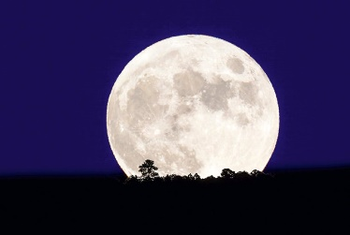 |  | As speakers we will…  Prepare and give a speech to our peers about a chosen key space figure.
Music
As musicians we will…
Compose, practice and present a piece of music to accompany our play scripts for our “Shoe-Box” theatres.
We will follow Charanga: Make You Feel My Love and The Fresh Prince of Bel Air.

 | Maths  As mathematicians we will…  Number  Study Multiplication and Division  Fractions  Problem Solving  We will use “Badger Problems.”  Shape and their Properties |  |  |  | D&T: Structures  Article 24: All children have the right to good health. Governments must work to provide clean water and nutritious food so that children can stay healthy.  Article 27: Every child has the right to a standard of living that is good enough to meet their physical needs. Governments must help families that cannot afford this.  As design technologists we will  Design and make a “Shoe-Box” theatre to present our play scripts to our reading buddies.
Computing
Article 17: Governments must help protect children from materials that could harm them (E Safety)
Article 16: Every child has the right to privacy. The law should protect the child’s private life.
Article 36: Governments must protect children from all forms of bad treatment.
As computing scientists we will…
Be able to code using “Kodu” to program about an alien landscape: we will write a sequence of instructions to test, evaluate and correct.
Be able to communicate through a “Power-Point” information about a planet.
Be able to communicate through an animation film our play script for our “Shoe-Box” theatres.
RE  Article 14: Every child has the right to think and believe what they want and to practice their religion, as long as they are not stopping other people from enjoying their rights.  Article 20: If a child cannot be looked after by their family, governments must make sure they are looked after properly by people who respect the child’s religion, culture and language.  Article 30; Every child has the right to learn and use language, customs and religion of their family, regardless of whether these are shared by the majority of people in the country where they live.  For spiritual and moral development we will question…  Has science got all the answers? The Big Bang Theory.  Compare different beliefs about the stories of creation: Christian, Hindu and Islam. |  |  |  | 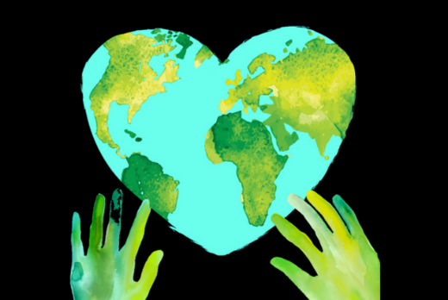  PSHE  As members of the community we will learn about…  Living in the wider World.

