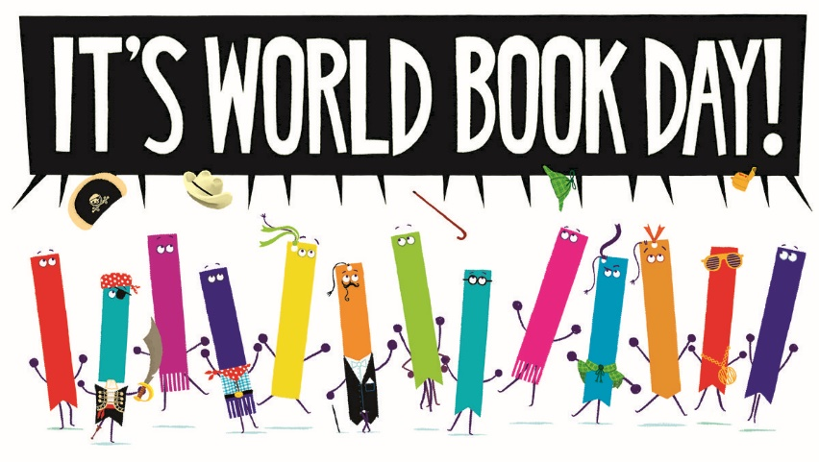
Next week it is World Book Week.
At Crowmoor will celebrate by sharing as many stories as we can – at home and at school.
The aim is to share a million stories across the World!
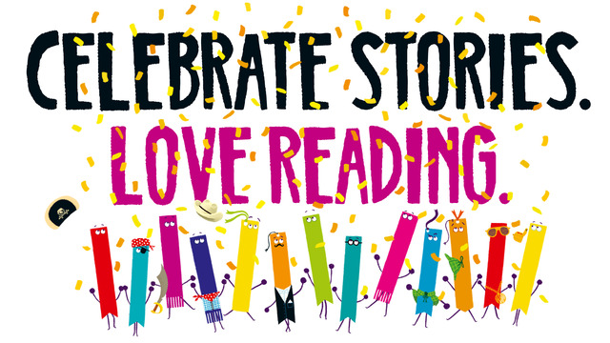

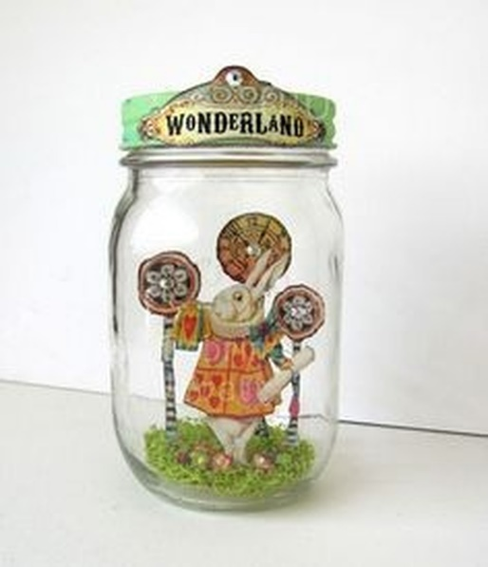
Competition…
We would like the children to make a book in a jar.

Dress-Up Day.
Thursday 5th March 2020
The children can choose any book character to dress up as - but we would like them to bring the book to go with their costume to share in class.
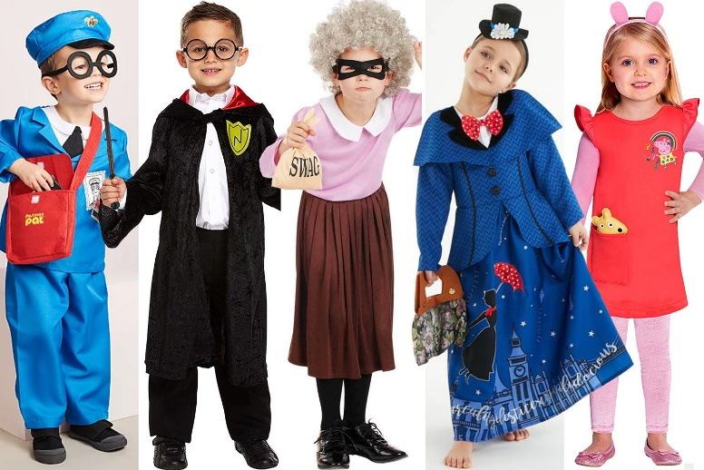
There will be a prize for the best costume in each class.
Mrs.P.

