Crowmoor Primary School & Nursery
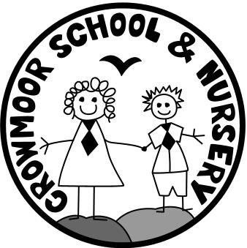
Crowmere Road
Shrewsbury
Shropshire
SY2 5JJ
Telephone: 01743 235549
Fax: 01743 243129

admin@crowmoorschool.co.uk
www.crowmoor.shropshire.sch.uk
Headteacher: Mr A J Parkhurst JP
Deputy Headteacher: Mrs J Parkhurst
School Business Manager: Miss H Cave

24th January 2020

Lunch Invitation – Chestnut Parents

Dear Parents/Carers,

We would like to give the parents of Chestnut Class an opportunity to come in to sample the excellent food on offer by Shire Services and to have a roast dinner with your child.
This will take place on Wednesday 5th February at 11:45 until 12:15pm.

Should you wish to attend, please fill out the response form below indicating what you would like for lunch. Spaces are limited, so it will be first come first served. Adults will need to pay for their lunch in advance at a cost of £3.00 per meal (including dessert). If we do not receive payment in advance for the adult meal, we cannot provide a lunch. We can only accommodate space for parents and not siblings outside of School. Unfortunately, we cannot accommodate parents that would like to bring in a packed lunch.
If you would like a sibling higher up the School to join you for lunch – please indicate this on the slip below.

Please return the response slip below with the money in a named envelope by 9am Friday 31st January.
If you have any questions please do not hesitate to contact the office.

Yours sincerely,

Nicola Preston.
Administrator
------------------------------------------------------------------------------------------------------------------------
Lunch Invitation – Chestnut - Wednesday 5th February 11.45am to 12.15pm

- I would like to join my child _______________________________ for lunch on Wednesday 5th February.
- I enclose £______ to pay for the cost of the meal.
- I would like my child/children higher up the School to join me ……..... Name…………………..

- I would like the Vegetarian option. YES/NO

