Washing throughout the day keeps the nasty bugs at bay

Shropshire Council’s public health team are reminding people across the county, in particular children, families and vulnerable adults, of the steps to take to help prevent the spread of Norovirus.
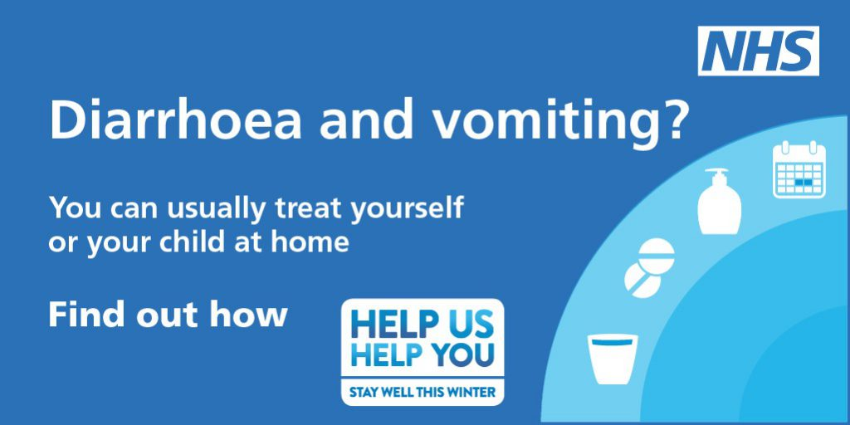
Norovirus
Norovirus, also called ‘winter vomiting bug’ because it usually occurs during the winter months, is the most frequent cause of infectious gastro-enteritis in England and Wales, and affects 600,000 to one million people in the United Kingdom every year.
It is highly contagious and is transmitted by contact with contaminated surfaces, an infected person, or by consuming contaminated food or water. These stomach bugs can also spread rapidly anywhere that people are gathered, such as schools or offices.
Cases usually start to appear during the autumn, peaking during January. The symptoms usually last from 12 to 60 hours, and will start with the sudden onset of nausea followed by projectile vomiting and diarrhoea.
Good hand hygiene can help to limit the spread of the infection, and there are some simple steps that you can take to help stop Norovirus spreading:
- Wash your hands frequently and thoroughly with soap and warm water, particularly after using the toilet, and before preparing food or eating.
- Disinfect any surfaces or objects that could be contaminated with Norovirus. It is best to use a bleach-based household cleaner. Always follow the instructions on the cleaning product.
- Flush away any faeces or vomit in the toilet. You should also keep the surrounding toilet area clean and hygienic.
- Wash any clothing, or linens, which could have become contaminated with Norovirus. Washing with hot, soapy water will help to ensure that the virus is killed.
- Although people usually recover without treatment in 12-60 hours, it is important to stay away from work, school, college or any social gatherings until you have been free of symptoms for at least 48 hours.
Rachel Robinson, Shropshire Council’s director of public health, said:
“We have recently seen an increase in Norovirus across Shropshire, so we just want raise awareness of the virus and what you can do to help prevent contracting it.
“Although an infection with Norovirus is self-limiting, and most people will make a full recovery in a few days, it is important to keep hydrated – especially children and older people.
“Also, with the current demand on health services across Shropshire, if you or your family members have had diarrhoea, vomiting or ‘flu-like’ symptoms in the last 48 hours, please try to avoid visiting A&E or GPs with symptoms, for at least 48 hours after their symptoms have gone, to prevent spreading the virus.”
Advice for parents and carers
How can you prevent the spread of these infections?
Hand washing is one of the most important ways to prevent the spread of both of these infections. This applies to the child who is ill and the person looking after them.
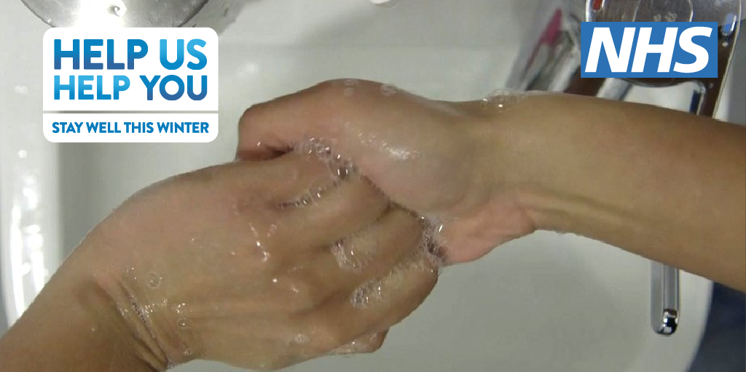

Hands should always be washed, using liquid soap if possible:
- Before and after caring for your child
- After using the toilet
- Before eating or handling food
- After cleaning up a mess (vomit, faeces or urine)
Children are particularly at risk of picking up infections and spreading them to other people. The NHS have released this song aimed at Children, to help teach them the proper handwashing technique. https://www.youtube.com/watch?v=S9VjeIWLnEg
Other ways of preventing the spread of infection are to:
- Keep a separate towel for family members who have symptoms
- Dispose promptly of used tissues and other items that your child may have coughed or sneezed on
- Wash soiled clothing, bed linen and towels in a washing machine. Use the hottest wash for that fabric
- Clean baths and washbasins thoroughly and disinfect after use
- If cleaning up diarrhoea or vomit, wash the surface with hot soapy water and disinfect before allowing to dry. If using bleach remember that it can remove the colour from fabrics and can burn the skin.
Please keep your child away from other children and people that are particularly vulnerable, eg older people and those with chronic illnesses.
For further information and advice visit https://www.nhs.uk/conditions/norovirus/.

