Crowmoor Primary School & Nursery
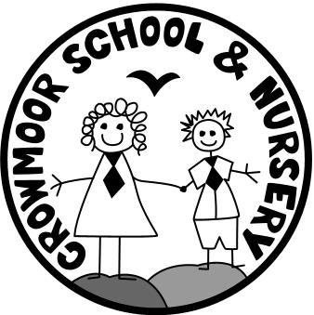
Crowmere Road
Shrewsbury
Shropshire
SY2 5JJ
Telephone: 01743 235549
Fax: 01743 243129

admin@crowmoorschool.co.uk
www.crowmoorschool.co.uk
Headteacher: Mr A J Parkhurst JP
Deputy Headteacher: Mrs J Parkhurst
School Business Manager: Miss H Cave

19th September 2019

Dear Parent/Carer,

Reception Baseline Assessment

The Reception Baseline Assessment (RBA) is a new national assessment that will be administered in all primary, infant and first schools in England to children in reception classes. It is a task-based assessment, using physical resources, focusing on communication, language and literacy, and maths. It will take around 20 minutes and will be completed with the Class Teacher or one of the reception class Teaching Assistants.

The RBA data will be used to judge how much progress children have made by the end of KS2 (Year 6 SATs). There will be no "pass" or "fail" or numerical score, and the results of the RBA will not be used to track individual pupils or to judge schools' Foundation Stage performance.

The Government has also stated that if the Reception Baseline Assessment check is introduced, children will no longer have to take KS1 SATs when they reach the end of Year 2. It's thought they'll be discontinued in 2023.

It will be officially introduced in the Autumn of 2020. Pilots are running in about 10,000 schools from September 2019. We are one of the pilot schools trialling the assessment this year so will be carrying the assessment out with our current Reception children.

If you wish to find out more information about the baseline assessment please see the following link:
https://www.nfer.ac.uk/for-schools/participate-in-research/information-about-the-201920-reception-baseline-assessment-pilot

If you have any further queries regarding this please do not hesitate to contact me.

Yours sincerely

Miss B Jones
Reception Class Teacher

