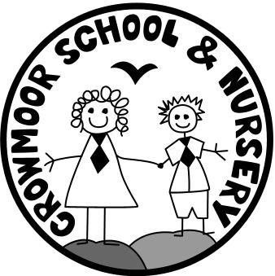
Crowmoor Primary School
Open Afternoon
Is your child due to start school in September 2020?
Come along to our open afternoon to meet the Headteacher and Class Teacher
Tuesday 8th October 2019
2pm: Welcome talk with the Headteacher
2:30pm: Tour of the school

To book please call the school office on 01743 235549
Please note, this open afternoon is for parents with children due to start school in Reception in September 2020 only.

