Crowmoor Primary School & Nursery
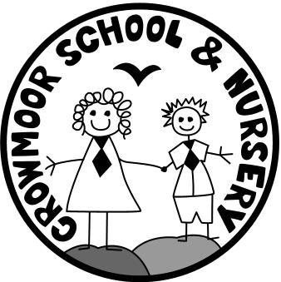
Crowmere Road
Shrewsbury
Shropshire
SY2 5JJ
Telephone: 01743 235549
Fax: 01743 243129

admin@crowmoorschool.co.uk
www.crowmoorschool.co.uk
Headteacher: Mr A J Parkhurst JP
Deputy Headteacher: Mr R Walsh
School Business Manager: Miss H Cave

9th July 2018

Dear Parent/Carer,

Unfortunately I am writing to inform you that there will be no Homework Club for the rest of the Summer Term.

Ms Nicholas as many of you are aware is off poorly and we have tried to cover her absence where we can. However, we are uncertain if we can cover it fully until the end of term and therefore, felt it would be best to give parents/carers as much notice as possible so alternative childcare can be arranged if necessary.

Letters for clubs next term will go out in September and we are hoping to be able to provide a similar more reliable service from September.

Please accept our apologies but we have explored all avenues and unfortunately cannot come up with a reliable plan for cover for the club.

If anyone has any queries regarding any of the above, please do not hesitate to contact me.

Yours sincerely

Miss H Cave
School Business Manager

