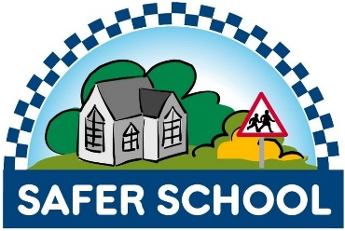

Crowmoor Primary School
Safer School’s Newsletter

November 2020

‘Safer Schools’

Ian Bartlett - Safer Schools
“As part of my attendance at the Crowmoor Primary School Safer School meetings, I would like to recognise Mr Parkhurst, governors, staff and pupils for their excellent working as an accredited Safer School. The school was accredited in 2010 and continues to comprehensively fulfil the Safer School criteria. A really positive approach to security and safety. At the recent Safer School meeting, attended by staff, pupils and West Mercia Police, the school was presented with a new Safer School certificate - congratulations!”

Ian Bartlett
Crime Prevention Officer
Shropshire Council

School Car Park

- Breakfast Club Drop Off. There have been concerns raised over the safety of children in the car park when they are dropped off at Breakfast Club.
We ask that you accompany your child safely across the car park and to the school entrance. If the current situation continues, we will have to stop vehicles coming onto the site and barrier will be down.
- Apart from School staff and timetabled visitors, only parents who are registered Blue Badge holders will be able to utilise the car park (when the barrier is in action).

The Safer School meetings are held on a termly basis and if you have any issues that should be looked at by this Committee, made up of staff, pupils, governors, police officers and council officials please pass them to the Office.
Year 6 pupils Louie and Isabella are our Safer School Representatives.

Parent Questionnaires

99% of the questionnaires that were returned were positive and had no concerns.

- The school has an excellent system and we feel very safe at all times.

- During pick up and drop off I feel staff have their IDs visible at all times.

- Crowmoor is a very safe and welcoming school. All staff are polite and happy to assist with any help and advice.

- It is good seeing teachers at drop off and pick up times by entrance and exits.

- I think it is a brilliant school. Can’t speak highly enough of all you do. Very grateful.

The pupils also completed the questionnaires.
The children commented that they felt safe and happy in School – that the site was secure.

Reminder
- As part of the schools safety procedures all pupils need to be in school by 8:40am because the cloakroom doors will be closed at 8:45am. If your child is late and arrives after this, the adult bringing them to school will need to sign them in at the office.
- If children are persistently late or off with authorised absences this will be picked up by the Schools Education Welfare Officer and she will take enforcement action.
- Please phone school on any day your child is absent.
- Please remember to update the Office with new phone numbers.

Many thanks, The Crowmoor Safer School Team

