Crowmoor Primary School & Nursery
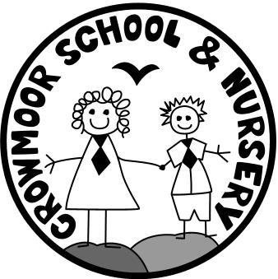
Crowmere Road
Shrewsbury
Shropshire
SY2 5JJ
Telephone: 01743 235549
Fax: 01743 243129

admin@crowmoorschool.co.uk
www.crowmoor.shropshire.sch.uk
Headteacher: Mr A J Parkhurst JP
Deputy Headteacher: Mr R Walsh
School Business Manager: Miss H Cave

Privacy Notices:

Data Protection Act 1998: How we use pupil information

We collect and hold personal information relating to our pupils and may also receive information about them from their previous school, local authority and/or the Department for Education (DfE). We use this personal data to:

- support our pupils’ learning
- monitor and report on their progress
- provide appropriate pastoral care; and
- assess the quality of our services

This information will include their contact details, national curriculum assessment results, attendance information, any exclusion information, where they go after they leave us and personal characteristics such as their ethnic group, any special educational needs they may have as well as relevant medical information.

We will not give information about our pupils to anyone without your consent unless the law and our policies allow us to do so. If you want to receive a copy of the information about your son/daughter that we hold, please contact:

Miss H Cave, School Business Manager

We are required, by law, to pass certain information about our pupils to our local authority (LA) and the Department for Education (DfE).

DfE may also share pupil level personal data that we supply to them, with third parties. This will only take place where legislation allows it to do so and it is in compliance with the Data Protection Act 1998.

Decisions on whether DfE releases this personal data to third parties are subject to a robust approval process and are based on a detailed assessment of who is requesting the data, the purpose for which it is required, the level and sensitivity of data requested and the arrangements in place to store and handle the data. To be granted access to pupil level data, requestors must comply with strict terms and conditions covering the confidentiality and handling of data, security arrangements and retention and use of the data.

For more information on how this sharing process works, please visit: https://www.gov.uk/guidance/national-pupil-database-apply-for-a-data-extract

For information on which third party organisations (and for which project) pupil level data has been provided to, please visit: https://www.gov.uk/government/publications/national-pupil-database-requests-received

If you need more information about how our local authority and/or DfE collect and use your information, please visit:

- our local authority at www.shropshire.gov.uk or

- the DfE website at https://www.gov.uk/data-protection-how-we-collect-and-share-research-data

Apart from the above, the only other time we share your child’s information is on our school website. Here we share their name for example, if your child was to win the weekly golden certificate their name would be published on the website and some children, if you have given permission for this in their admission forms are included in pictures on our school website.

The pictures can often remain on our website for the duration of your child’s time at Crowmoor and even when they have left us.

If you are not happy with the above regarding your child’s name and or picture you must notify the school in writing by Monday 4th June 2018. If we do not hear from you by the end of the school day (3.15pm) on this date we will assume that you are happy for your child’s name where necessary to be included and their picture if you have already given permission on the admission forms, on our school website (www.crowmoorschool.co.uk)

If you did not give permission for your child’s photo on those initial admission forms you do not need to worry as we will continue to not allow them have their picture on the school website.

If you wish to review any permissions we have for your child please speak to the school office who will be able to look into this for you.

If you have any queries regarding the above, please do not hesitate to contact me.

Yours sincerely

Miss H Cave
School Business Manager

