Crowmoor Primary School & Nursery
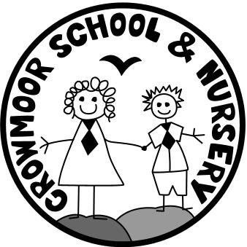
Crowmere Road
Shrewsbury
Shropshire
SY2 5JJ
Telephone: 01743 235549
Fax: 01743 243129

admin@crowmoorschool.co.uk
www.crowmoor.shropshire.sch.uk
Headteacher: Mr A J Parkhurst JP
Deputy Headteacher: Mr R Walsh
School Business Manager: Miss H Cave
13th December 2017
Dear Parents/Carers

We have great pleasure in sharing the OFSTED inspection letter from our recent short inspection with you. We are very proud of the work that the staff and pupils do to ensure that your children get the best possible from their primary education. We are very pleased to have retained our Good rating. This was not an easy achievement under the current inspection regime.

This fantastic result has only been achieved in partnership with yourselves. We rely on parents and careers helping with the homework, listening to children read and generally being supportive of what we are trying to achieve in school. To ensure that our pupils and your children succeed. Thank you to all the parents who commented on the school, this helped get us the great result we got.

As the letter states we know what we need to do to get even better and have clear plans to achieve in these areas. Some of the development points can be achieved in school alone, with some of them we will have to rely on you to help us achieve them. For example, attendance at school remains an issue for both us and OFSTED. If pupils are not present or are late they simply cannot learn effectively. If you are having problems in getting your children to school on time or at all, please contact the Office and we will do our best to support you.

We hope when you read the inspection letter that you are as proud as we are of what the school, the parents, pupils, staff and governors have achieved together. In continuing this partnership we are confident that we can continue to build on our success in the future. As the OFSTED inspector told us “I am confident the school will go from strength to strength.”

Yours sincerely

Alan Parkhurst John Faherty
Headteacher Chair of Governors

