Crowmoor Primary School & Nursery
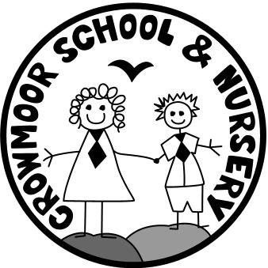
Crowmere Road
Shrewsbury
Shropshire
SY2 5JJ
Telephone: 01743 235549
Fax: 01743 243129

admin@crowmoorschool.co.uk
www.crowmoorschool.co.uk
Headteacher: Mr A J Parkhurst JP
Deputy Headteacher: Mrs J Parkhurst
School Business Manager: Miss H Cave

POST: KS2 Class Teacher
SALARY GRADE: MPS/UPS
POST STATUS: Fixed Term until the end of the Summer Term 2019
START DATE: 25th February 2019

We are seeking to recruit an enthusiastic and effective class teacher to join our increasingly successful team. You must be a proven creative and imaginative practitioner, able to motivate and inspire children to achieve their best, regardless of background or ability, enabling them to become independent motivated learners.

We want a committed individual to help our supportive team build on our recent ‘Good’ OFSTED Report and to help make our school outstanding.

Please state your subject interests and strengths in your application.

Closing Date: 14th December 2018 12 noon Interviews: 16th January

If you have not heard by close of business on the 14th December, please assume your application has been unsuccessful on this occasion.

NQT’s are welcome to apply.

The school is committed to safeguarding the welfare of its pupils and the successful applicant will be subject to a full CRB check.

