Crowmoor Primary School & Nursery
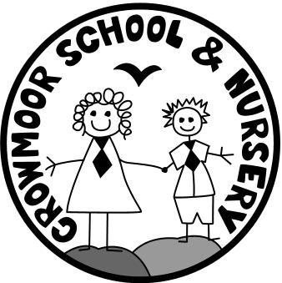
Crowmere Road
Shrewsbury
Shropshire
SY2 5JJ
Telephone: 01743 235549
Fax: 01743 243129

admin@crowmoorschool.co.uk
www.crowmoor.shropshire.sch.uk
Headteacher: Mr A J Parkhurst JP
Deputy Headteacher: Mr R Walsh
School Business Manager: Miss H Cave

POST: Deputy Head Teacher SALARY GRADE: Group 2 Leadership Scale 3-7
POST STATUS: Permanent from September 2018
Required a Deputy Head for this consistently OFSTED rated Good School!
Do you fully believe that education should and can improve the life chances of all children, not just a select few?
If the answer to the above is yes we look forward to receiving your application form to be the next Deputy Head at our fully inclusive community focussed Co-operative school. We seek to open our doors to all.
We don’t accept that background and past behaviour predicts the success of any child. We, the ‘Crowmoor Team,’ -staff, parents, governors and pupils- want a very special person who has lots of dedication and commitment to work with us in our extra-special school.
Our staff are looking for a proactive Deputy Head Teacher to help lead them from the front. They want the successful candidate to have the following qualities:
* An educational vision, with a clear sense of moral purpose with the ability to inspire and motivate
* The commitment, positive enthusiasm and optimism to always put the interest of pupils first, striving for themselves and the school to be better and better
* Steadfast in challenging under-performance or poor behaviour
* Having the resilience and imagination to proactively come up with solutions to issues not being defeated by them
* Being outward-looking and curious, using all opportunities and networking to pick up good ideas from elsewhere
* Remaining calm in a crisis, having great judgement. Having the courage to make the right decision even if unpopular
* Empathy and persuasive team-building skills to take people forward together. Being open, trusting and trusted, a genuine listener showing mutual respect to the views and ideas of all
* Passion about teaching and learning and show great commitment to children. They take an active interest in their pupils' work – and that of their staff
* Being human, being prepared to acknowledge you can get things wrong like everyone else
We want everyone at Crowmoor to be the best they can be and will actively support you in your career aspirations. If you want promotion we can provide the skills and experience to make it happen.
Visits to the School are actively encouraged- Details can be found on our school website.
Please contact the Headteacher, Alan Parkhurst, for an informal chat.
Closing Date: Monday 14th May at 12 noon Interviews: Tuesday 22nd and Wednesday 23rd May
The school is committed to safeguarding the welfare of its pupils and the successful applicant will be subject to a full DBS check.

