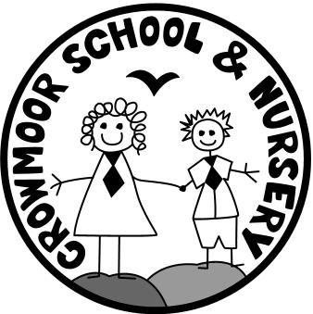

Results

Key Stage Two:
Average scale scores in Reading & Maths
Reading | Maths
103.3 | 103.7

Percentage of pupils who achieved expected standard or above in Reading, Writing and Maths
Reading | Writing | Maths
69% | 79% | 66%

Percentage of pupils who achieved high level of attainment in Reading, Writing and Maths
Reading | Writing | Maths
14% | 17% | 21%

Average progress scores in Reading, Writing and Maths

Reading
Writing

Maths
Key Stage One:
2018/2019 Results
 | Whole Class 29 |  |  |  | Pupil Premium 13/29 |  |  |  | Non Pupil Premium 16/29
 | Pre KS | WT | >EXS | GDS | Pre KS | WT | >EXS | GDS | Pre KS | WT | >EXS | GDS
Reading |  | 6  21% | 23  79% | 5  17% |  | 2  15% | 11  85% | 2  15% |  | 4  25% | 12  75% | 3  19%
Writing/GPS |  | 7  24% | 22  76% | 3  10% |  | 2  15% | 11  85% | 2  15% |  | 5  31% | 11  69% | 1  6%
Maths | 1  3% | 6  21% | 22  76% | 4  14% | 1  8% | 2  15% | 10  77% | 2  15% |  | 4  25% | 12  75% | 2  13%
Science |  |  | 24  83% |  |  |  | 11  85% |  |  |  | 13  %
RWM |  |  | 19  66%

