Lower Key Stage 2 Multiplication Tables Support

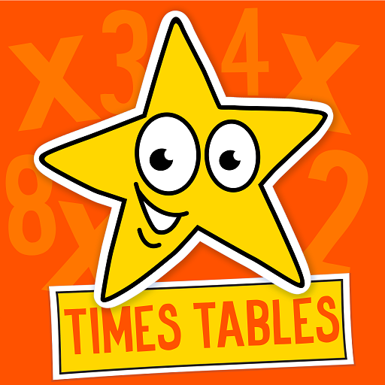

Multiplication Tables are so important for children to learn. As the children progress throughout the school, they will use them more and more within their maths. By helping your child learn the times tables you will help ensure they access the curriculum more efficiently and you’ll assist them becoming more confident mathematicians.

The following objectives are year group statements/expectations from the current maths curriculum:

Year 3
- To recall and use multiplication and division facts for the 3, 4 and 6 multiplication tables
Year 4
- To recall multiplication and division facts for the 7, 8, 9, 11 and 12 multiplication tables

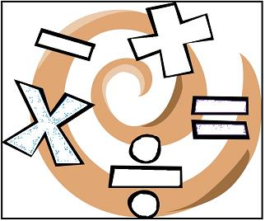

Why are times tables important?
You would be amazed at how much of our maths at school and in real life is based on tables. It is important that your child knows all of their times tables (up to 12x12) by the end of Year Four. With effect from the 2019-2020 academic year your child will take a Statutory Times Table test at the end of their time in Y4. With your help and practice in school we will ensure your child is ready to take the test and have more of a chance of succeeding. We appreciate the expectation is high but we must work together to ensure your child achieves their maximum potential. If you would like advice as to where your child is in relation to the Year Group expectations please consult with your child’s Class Teacher.

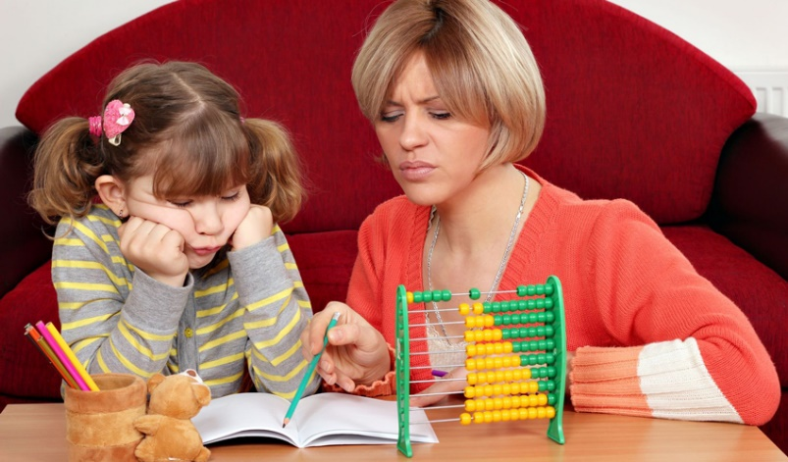

How you can help
There are masses of maths games online, including ones to help your child with their tables. NumberGym can be downloaded as an app at home and is used in school. Please see the recommended multiplication table website list at the end of this document.

The following advice might assist in making learning times tables fun at home:

Age 7 – 9
- Build up new times tables gradually and keep on practicing the ones they know already
- Chanting times tables is a good way of practicing facts they already know
- Encourage them to say their tables backwards as well as forwards. Saying them in reverse order, from 10 back to 1 will help to find ways of figuring out the ones they keep forgetting
- Number hunt - how many different ways can they find to make 36 – or 48 – or 21?
- There are certain key facts that are useful and easy to remember (they include the doubles, the 5 and 10 times tables and the square numbers such as 3 x 3 = 9)

Useful tips to help your children to learn their tables at home
- When your child has begun to learn a table, practise the table for five minutes each day with them
- It is important to say the whole table, not just the answers, again and again and again and again!
- Break down each table into manageable chunks. For example, ask them 1 x 6, 2 x 6 and 5 x 6 until they know the answers then add the next one
- Work on pairs of tables, for example if your child is learning the two times table they can use their doubling facts to calculate the four times tables
- Test your child by firing questions at them, out of order reminding them that they can use facts that they are confident with to work out trickier ones. For example if they know 4x6=24 just double to find 8x6
- Keep checking that they still know the facts they have learnt and revisit previously learnt facts
- Encourage your child to write out the table they are learning again and again, perhaps as a spider diagram grouping the facts that they are confident with and those which they are less confident with. Display tables around different parts of the house so that your child sees them everywhere (even in the bathroom!)
- Use a range of vocabulary—times, multiply, lots of, sets of…
- Perhaps mix art activities with facts they are learning…

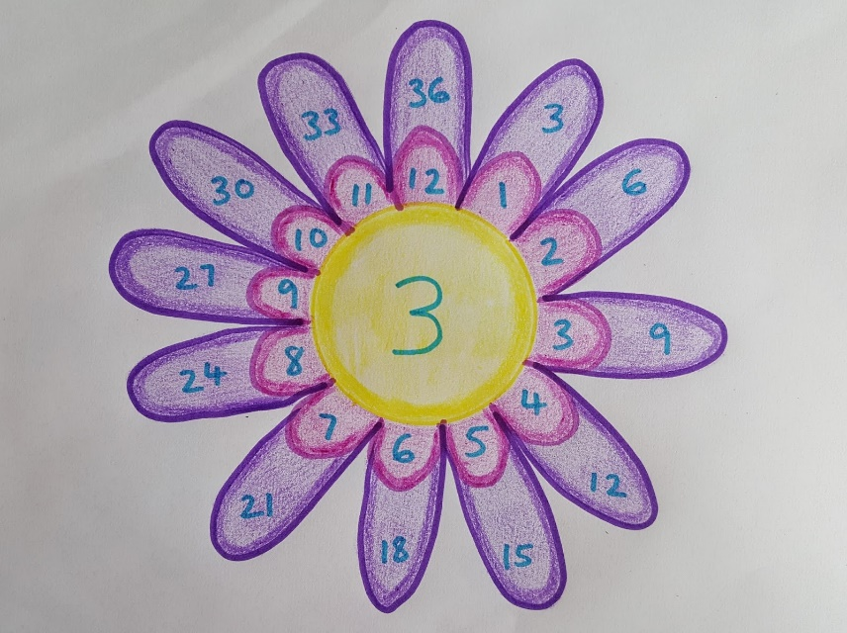

Make it fun!
Think of catchy rhymes to help your child remember a tricky table.
Can you make some up?
I skate and I skate on a slippery floor becomes 8 x 8 = 64
Look for patterns or clever tricks, for example, you can rearrange 7 x 8 = 56 to 56 = 7 x 8. The numbers are now in order - 5, 6, 7 and 8!
If your child has learnt their four times tables, they can double these to learn the eight times tables.
Say tricky tables in silly voices or even try singing them. Even young children learn song lyrics very quickly and easily!
See if you can remember your times tables! Let your child test you! Remember, practice makes perfect!
Use a multiplication square
To use a multiplication square, choose a number from the first column and a number from the first row. Follow the row and column until they meet in the middle, for example, 6 x 7 = 42.
Try blanking out some of the numbers. Does your child know what numbers are missing?
Look for patterns!
How many calculations have the same answer?

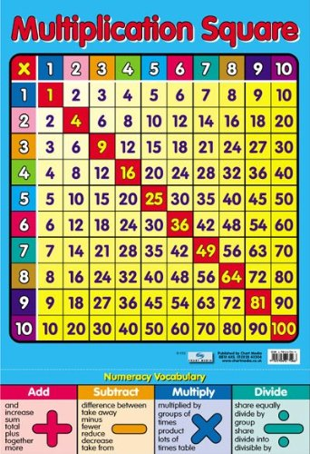
Try these websites!
Recommended interactive multiplication games:
http://www.multiplication.com/interactive_games.htm - offers a wide range of games collected from different websites. Fantastic!
NumberGym (times table and number bond practice): http://www.numbergym.co.uk/ - we use this in school and your child knows their log in detail.
BBC skillswise at: www.bbc.co.uk/skillswise/numbers/wholenumbers/multiplication/timestables/index.shtml
http://uk.mathletics.com/ - Mathletics has a variety of multiplication activities and games, again your child knows their log in detail.
http://12xtables.co.uk/ - click on your child’s year group on the top icons then select times tables.
http://www.ictgames.com/resources.html - KS1 program to help in the early stages of times tables.
https://www.mathsisfun.com/timestable.html - good for tables practice and activities.
http://www.maths-games.org/times-tables-games.html
http://www.crickweb.co.uk/ks2numeracy-multiplication.html

