Key Stage 1 Multiplication Tables Support

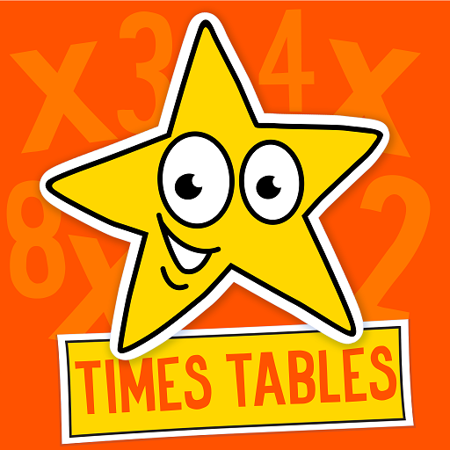
Multiplication Tables are so important for children to learn. As the children progress throughout the school, they will use them more and more within their maths. By helping your child begin to learn their times tables you will help ensure they access the curriculum more efficiently and you’ll assist them becoming more confident mathematicians.

The following objectives are year group and school statements/expectations from the current maths curriculum:

EYFS/Reception Class
- To count in multiples of 10
Year 1
- To count in multiples of twos, fives and tens
- To know the two times table
Year 2
- To recall and use multiplication and division facts for the 2, 5 and 10 times table

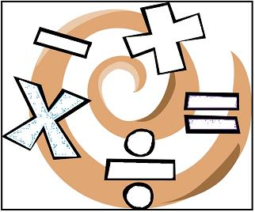

Why are times tables important?
You would be amazed at how much of our maths at school and in real life is based on tables. It is important that your child knows all of their times tables (up to 12x12) by the end of Year Four. The learning of times tables is taught in stages and as a result it is very important that your child is secure with their 2s, 5s and 10s by the time they move up to Lower Key Stage 2. Your child will take a Statutory Times Table test at the end of their time in Y4 at which point they will have learnt the remaining tables and their division facts. With your help and practice in school we will ensure your child is Lower Key Stage 2 ready. We appreciate the expectation is high but we must work together to ensure your child achieves their maximum potential. If you would like advice as to where your child is in relation to the Year Group expectations please consult with your child’s Class Teacher.

How you can help
There are masses of maths games online, including ones to help your child with their tables. NumberGym can be downloaded as an app at home and is used in school.

The following advice might assist in making learning times tables fun at home:

Age 5 – 7
Encourage your child to practice counting in 2s, 5s and 10s.
Try some of these strategies:
- Counting parts of the body such as hands, ears, fingers, etc. One person – how many hands? Two people – how many hands? One dog – how many paws? Two dogs – how many paws? One hand – how many fingers? Two hands – how many fingers?
- Counting 2, 5 and 10 pence coins
- Reciting number rhymes such as ‘One, Two, Buckle My Shoe’
- Talk about odd and even numbers (make pairs from piles of socks, shoes or gloves) - this helps children to understand the concept of odd and even
- Try counting steps on a walk or going up the stairs

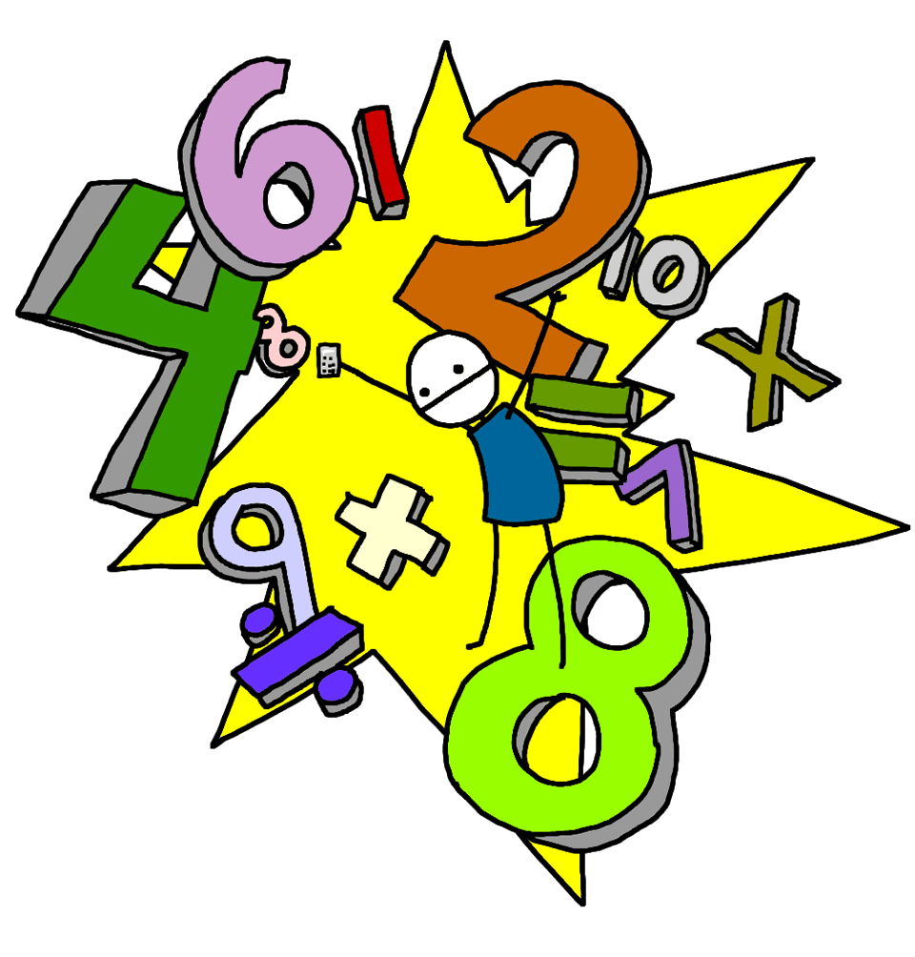
Make it fun!
Think of catchy rhymes to help your child remember a tricky table. Can you make some up?
Look for patterns or clever tricks.
If your child has learnt their two times tables remind them that they are doubling a number.
Say tricky table facts in silly voices or even try singing them. Young children are great at learning song lyrics!
See if you can remember your times tables! Let your child test you! Remember, practice makes perfect!
Nearer Y3 start introducing the concept of a multiplication grid.
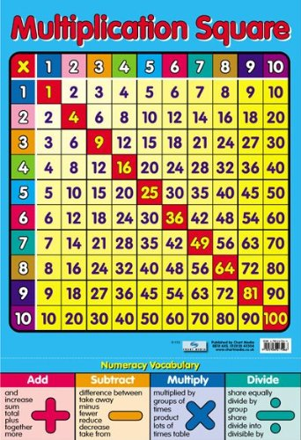
Try these websites!
Recommended interactive multiplication games:
http://www.multiplication.com/interactive_games.htm - offers a wide range of games collected from different websites. Fantastic!
NumberGym (times table and number bond practice): http://www.numbergym.co.uk/ - we use this in school and your child knows their log in detail.
http://uk.mathletics.com/ - Mathletics has a variety of multiplication activities and games, again your child knows their log in detail.
http://12xtables.co.uk/ - click on your child’s year group on the top icons then select times tables.
http://www.ictgames.com/resources.html - KS1 program to help in the early stages of times tables.
https://www.mathsisfun.com/timestable.html - good for tables practice and activities.
http://www.maths-games.org/times-tables-games.html

